How to Create a Symbolic link for DCS World

Open the CMD window by hitting the windows key and typing CMD and selecting run as administrator.

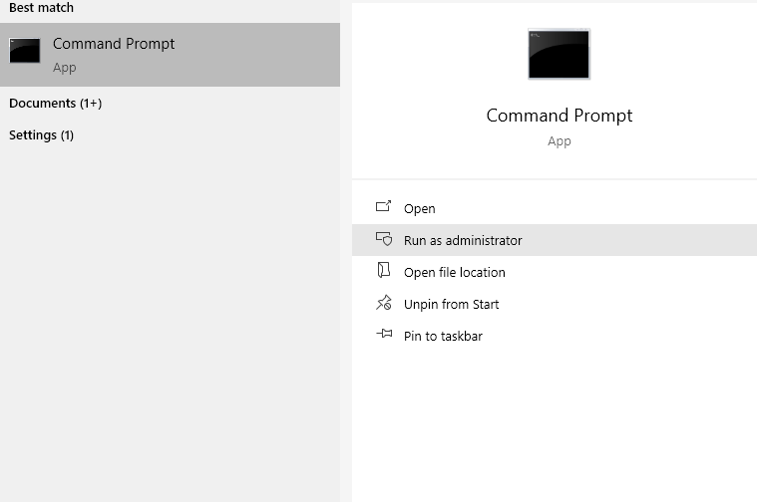

Once the command window is open, type the following:

mklink /J

Leave this for now we will come back to this later as we will add more to this command.

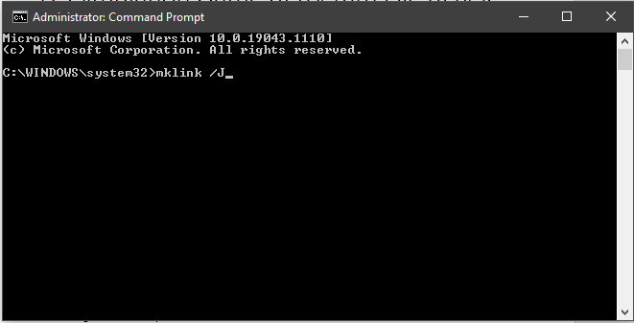
Next, we need to re-name the main DSC World OpenBeta folder as the command we are going to run will recreate a new DCS folder of the same name with a symbolic link (shown below as a chain next to the folder)
This is what I used: DCS World OpenBeta.bak (The .bak will make it folder unique)
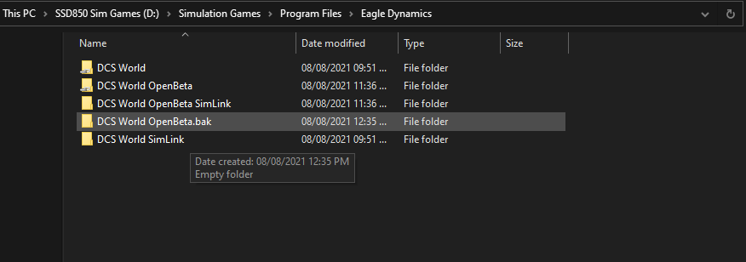
Next, we add this path to the CMD window
“D:\Simulation Games\Program Files\Eagle Dynamics\DCS World OpenBeta”
Don’t run the command yet!
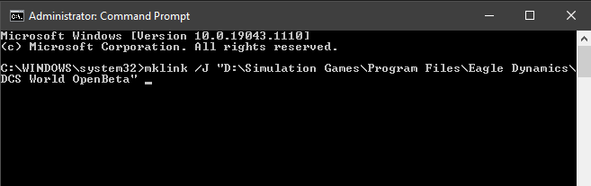
When you finally Run the command with \DCS World OpenBeta added to the file path it will recreate the folder as a new symbolic link folder.

Important.
If you don’t rename the OpenBeta folder the command will not work as it cannot recreate or overwrite existing folder of the same name.

Next…...

Make a brand-new folder on the same drive (or any drive of your choice), call this new folder whatever you want however my suggestion would be to use something easy to remember.
This is what I used: DCS World OpenBeta SimLink
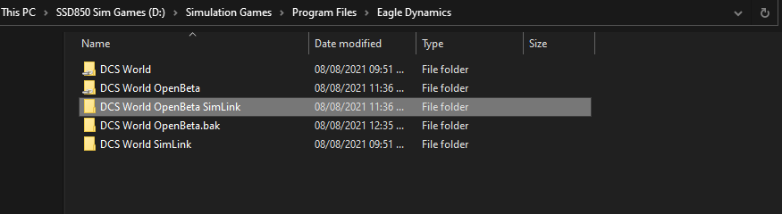
The final file path we now need to add to the CMD window will be this new folder.
“D:\Simulation Games\Program Files\Eagle Dynamics\DCS World OpenBeta SimLink”
The whole command should now look like this:
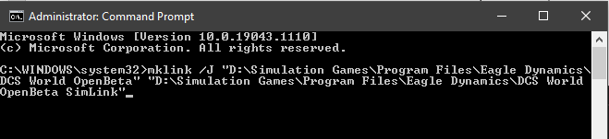
Pay attention to lettering and the spacing otherwise the command will not run, make sure there is a space between the end of the first path and the beginning of the next folder path (“ “)

Run the command…….

Once you have hit enter you will get confirmation shown below (ignore the file path as this was an example I had to paste from the internet as I had already run this myself)
What you are looking for is and the showing the link created between the two folder paths.

Congratulations! you have now created a link from the DCS folder to the simlink folder

Now cut and paste the contents from the beta folder into the simlink folder.
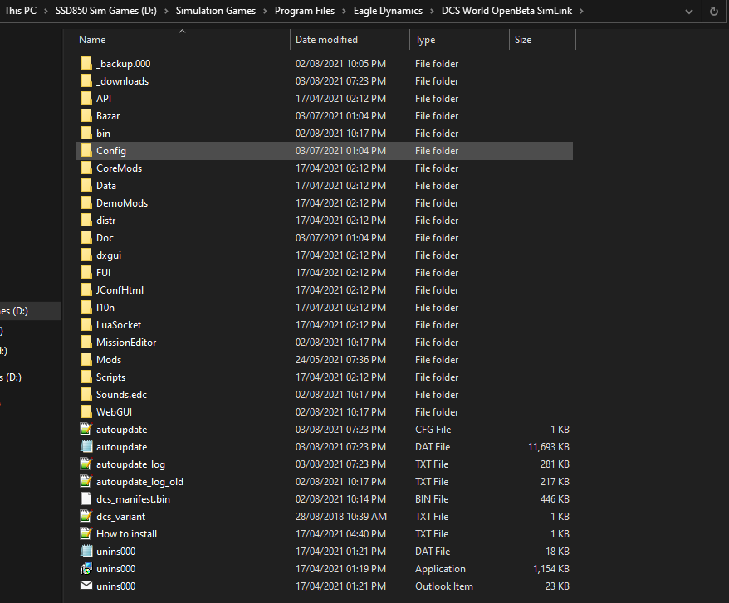
Open the DCS World OpenBeta folder by double clicking on it, you will immediately notice the contents is still where it was before you started, that’s because the symbolic link is pointing DCS to the new folder completely unaware the location of the game files have now changed. This will not affect any game updating.

Here is the final folder structures I have with the .BAK files removed as they are now empty

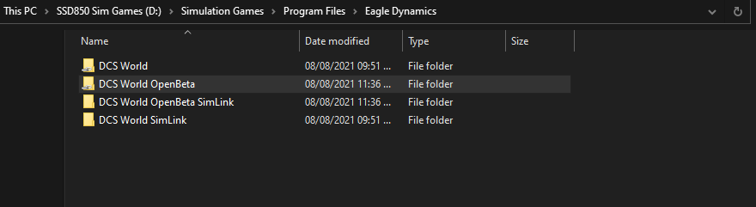
Final notes.
Your performance will vary depending on your system and settings however, the goal is to establish a more consistent frame rate across single player and multiplayer environments.
By stopping windows from committing large commonly used files constantly being accessed and forcing them into memory on top of DCS, it will clear more memory for DCS related textures and other background files being used in the DCS program.
Windows was programmed/designed to allow commonly accessed files to be committed to Virtual memory to facilitate performance and add productivity for large file manipulation, however this can be problematic when games use considerable amounts of system memory for textures, scripts, sounds ect, By moving the files outside the program executable but maintaining the path tricks windows into thinking that these files are no longer being commonly accessed thus freeing up memory for DCS to use without interference from windows OS.

Disclaimer:
If you screw this up its on you! Google mklink /J if you want more information.

Happy flying!!
23rd_RuskyV

