Cyclic Ops:
What is cyclic ops: Cyclic Operations refers to the continuous process of launching and recovering aircraft. To maximize efficiency, aircraft are launched and recovered in groups or "cycles." Cyclic Ops is how the aircraft carrier operates as a moving airbase and is considered the NORM in the US Navy. It is used during training and real-world missions. It is NOT used for qualifying or requalifying pilots. Just like an airbase, a pilot will takeoff, execute his mission, and then land. There are no repeated launches and landings like during CQ, although repeated landing attempts might occur if an aircraft bolters or has been instructed to wave-off by the landing signal officers.

Why cyclic ops?
Whereas an airfield is continuously open, and you need only to call the tower when you want to land, the ship is only open for launch and recovery operations at specific times. Operating limitations do not allow the carrier to operate continuous launches and landings. Space will be the main cause of this limitation and as you can imagine and if the carrier would continuously sail into the wind, it would never reach its destination, or potentially run aground.

How long do those cycles last?
Each cycle is approximately one hour and thirty minutes long (1+30 cycle). Although cycles as short as an hour or as long as an hour and 45 minutes are not uncommon. ATO requirements may necessitate longer or shorter cycles. Longer cycles can accommodate more launches and recoveries, while shorter cycles limit the number of aircraft that can be launched or recovered. The cycle time also has an impact on fuel for airborne aircraft. Longer cycles may necessitate additional tanking.

How many aircraft get launched/recovered in a cycle?
Each cycle, or event, is usually made up of 12-20 aircraft. These events are sequentially numbered and correspond to the respective cycle in the 24-hour fly day. Event 1 corresponds to the first cycle, Event 2 to the second cycle, and so on.
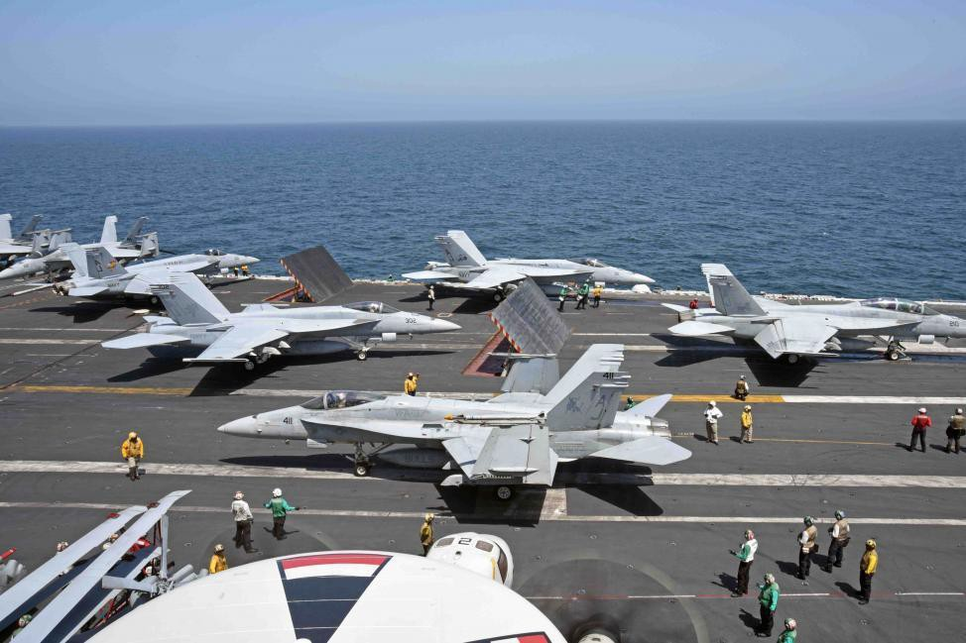

The Airplan:
Every day, an airplan will be created for the following day. The airplan is a flight operations schedule for every squadron aboard the ship. The airplan is constructed based on what missions are required, which training is desired, how many airplanes the squadrons have “up,” and what the ship is physically able to support. Contrary to popular belief, the ship cannot just launch dozens of planes and recover dozens of planes every hour. So, the squadron operations officers meet with the ship’s air operations officer to work together to come up with an airplan. The airplan is signed by CO of the aircraft carrier. Based off this airplan, each squadron will write its own flight schedule.

The airplan will show all the “events” for the day. The length of time between each event is called a cycle as we previously described. Usually, each fighter squadron will send up 2-4 jets per event, but not every single event.

For example:
During a typical 8-event day (not to say 8 events is the standard number; it’s just a common one), a squadron may send up aircraft during events 1,2,3,5,7,8...and a different squadron may do 1,2,4,5,6,8. Again, all of that was predetermined at the airplan meeting to spread out airplanes throughout the events to not overwhelm the ship.

Usually, fighter aircraft are up for a single cycle at a time. Infrequently, they may use tanker gas to go
“double cycle.” For example: A jet usually plans to launch in event 1 and plan to land in event 2. Infrequently, a jet will launch in event 1 and land with event 3 after having gotten extra fuel from the tanker.

In combat, however, with numerous AAR in country, a fighter will land 4 or so events later. Aircraft such as the E-2 Hawkeye are usually up double cycle or triple cycle in training, and also can be longer for combat missions. There are even more nuances to the airplan: Tankers typically launch 10 minutes prior to the scheduled launch time for the event. Big wing aircraft also go early (5 or 10 minutes).

Recovery Tankers can also do “yo-yo tanking” where they launch and recover in the same event. Missions tankers are single cycle, however. This brings up another difference from CQ: there are no tankers in CQ. During cyclic Ops there is one recovery tanker, and sometimes one or even 2 Mission tankers).
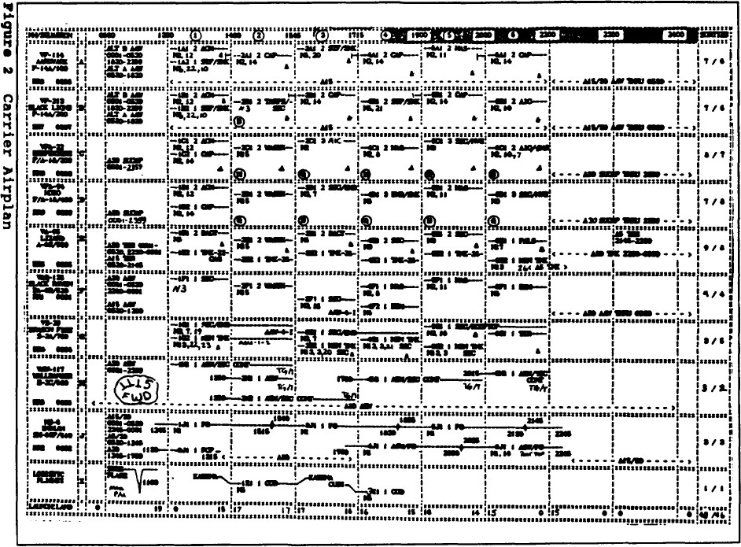

The Launch Sequence Plan (LSP):
Prior to launch, it is normal practice that the sequence of launch is determined by a Launch Sequence Plan “LSP” that the Handler is aware of. If no LSP is used, then the launch order will be primarily be determined by parking spots. This could cause aircraft working together on the same
mission being launched out of sequence. Therefore, aircraft working together on the same mission will be required to rendezvous when airborne.

Spotting Aircraft:

Prior to flight operations, the aircraft on the flight deck are arranged ("spotted") so that Event 1 aircraft can easily be taxied to the catapults once they have been started and inspected.
Once the Event 1 aircraft are launched, which generally takes about 15 minutes, Event 2 aircraft are readied for the next cyclic launch. The launching of aircraft makes room on the flight deck to land aircraft.
Once Event 2 aircraft are launched, Event 1 aircraft are recovered, fueled, re-armed, re-spotted and readied to be used for Event 3.
Event 3 aircraft are launched, followed by the recovery of Event 2 aircraft (and so on throughout the fly day/night).
After the last launch of the night, all the aircraft are generally stored up on the bow in order to keep the landing area clear until the last aircraft lands. They are then re-spotted about the flight deck and secured until the next morning's first launch.
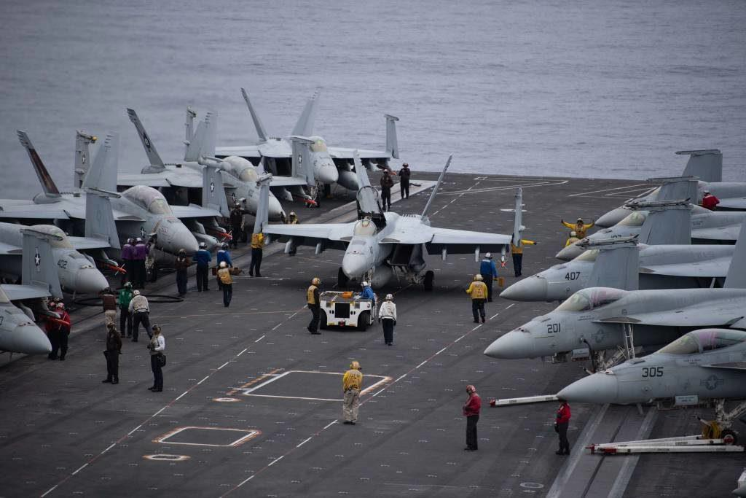

Rendezvous after launch:
As mentioned before, aircraft working together on the same mission might be launched out of sequence. This will require them to rendezvous when airborne. This is accomplished at a predetermined location, usually at the tanker, overhead the carrier or at an en-route location. The location is pre-briefed and often depends on what the mission will be.
More often, jets will launch less neatly, and your lead/wingman may launch several minutes before or after you. In this common case, you would meet at the prebriefed point. For training/local missions this is almost always at the overhead tanker or the overhead holding altitude. However, for combat missions going in country, you would likely meet en-route. This can be done without spending much gas.

For example:
The aircraft launching first can do a 90 degree turn away from course to allow the following aircraft to catch up using geometry.
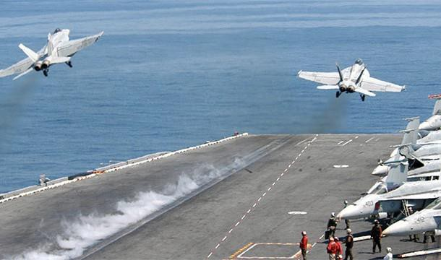

Aircraft are normally launched with a 30 second interval but could be launched together by launching 1 aircraft from the bow (Cat 1 or 2) and one aircraft from the stern (Cat 3 or 4). This is called a “covey launch.” It is important to note that covey launches only occur during Case I departures. Case II and III do not allow covey launches to take place.

If the covey launch occurs between 2 unrelated aircraft. Then they will just fly parallel at 300kts and 500 ft and at the end of the departure each go separate ways. If the covey launch occurs between two aircraft of the same formation, then one of two things will happen. Most frequently, the Boss will say “cleared to join” right after the jets are safely airborne and they can fly together. This will mean that it is perfectly fine for wing to accelerate and join up with the lead right away before reaching 7DME, however the Case I departure altitude of 500ft AGL will have to be adhered to. Less often, the Boss will not say anything, and they will join up after 7 miles.

How does this affect fuel planning?

Fuel planning is an absolutely huge subject when it comes to operating from a carrier. Remember how the ship is not open all the time like an airfield? Well, that means pilots needs to be nearly obsessed with watching their fuel.

Fuel planning is a time-distance problem and is managed by using a “fuel ladder.” In each air wing, CAG will demand a minimum amount of fuel to show up in the groove with. We call this number “Tank state + X”. The “ + X” indicates the number of additional passes that can be performed prior to reaching “tank state.”

Let’s suppose that CAG determines that the legacy Hornet tank state is 3.0 (it is different per aircraft type). Let’s also suppose CAG says that the minimum fuel to show up in the groove with is Tank State plus 2 additional passes (written as T+2 and pronounced as “Tank plus 2”).

We assume the following numbers:
- A go around the pattern during case 1 and 2 will take 500 pounds of fuel.
- A go around the pattern during case 3 will take 1000 pounds of fuel

In this example, T+2 would be:
Tank state of 3000 + (2x 500) = 4000 pounds during case 1 and 2
Tank state of 3000 + (2x 1000) = 5000 pounds during case 3.

4000 and 5000 represent this example’s minimum fuel state to show up with “on the ball” (slang for
in the groove).

If you bolter or wave off after your first pass you are now considered T+1. If you do so again then you are now considered TOB (“tank on the ball”). If you do so again you will now go to the tanker. Usually after you bolter or wave off after your T+1 pass the tanker will be instructed to “hawk” you and be in a position for you to easily and quickly join up if you go around again.

Introduction to the Fuel Ladder:
We know how much fuel to arrive on the ball with and how much fuel we use around the pattern. Fuel technically is meaningless if you do not know how much time a certain amount of fuel will buy you. Therefore, we must find a way to create awareness on where we are “time and fuel” wise and what we can do with this information in relation to getting back safely to the boat. That is where the Fuel ladder comes in.

*** IMPORTANT, TANK STATES ARE USED DURING CYCLIC OPS. EVEN IF THE BOAT IS NOT OPERATING BLUE WATER AND DIVERTS ARE AVAILABLE ***
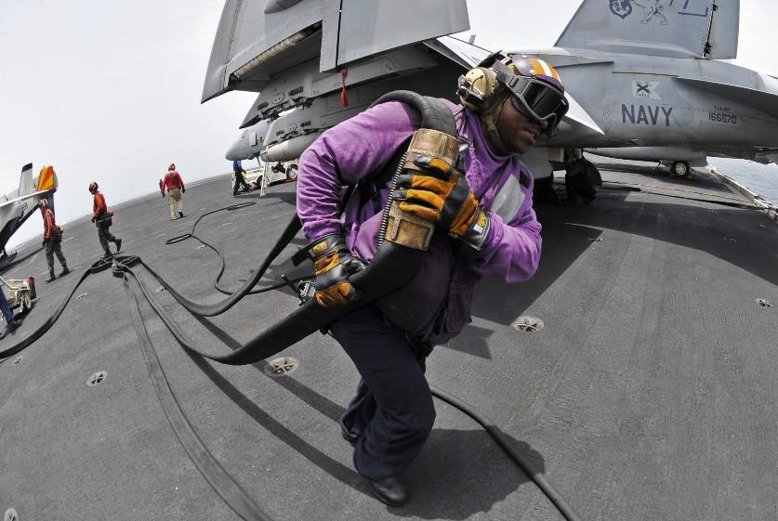

Fuel Ladder:
The fuel ladder is built on the assumption that the legacy hornet will burn 1200 pounds every 15 minutes AT MAX ENDURANCE speed. How do we know our max endurance speed? A rough number for the legacy hornet is 250 KCAS. A more accurate way of determining your MAX ENDURANCE SPEED is flying 5.6 AOA or use the Flight Performance Advisory Page known as (FPAS). Again, this burn rate is different for each aircraft.

In this example we will use the following:
- A tank state of 3.0
- CAG requires you to be T+3 on the ball
- Case 1 cyclic operations
- You launch in event 1 at time 1100.
- You will be on a 1+15 cycle.

Now we need to determine when we land. You might say 1215 because it is a 1+15 cycle, but you’d be wrong. Remember, landings occur AFTER launch. Therefore, you’d be landing a few minutes after 1215, but a good and conservative number is 15 minutes for the launch. Therefore, on your 1+15
cycle you’d be landing at 1230.

Now let’s build our ladder, which is constructed backwards from land time: We expect now to land at 12:30 and CAG wants us to be on the ball with T+3.
T+3 = 3000 pounds plus 3 additional case I pattern passes of 500 pounds. So T+3 = 4500 Pounds.

Time: | Fuel Required:
1230 | 4.5 (T+3)
1215 | 5.7
1200 | 6.9
1145 | 8.1
1130 | 9.3
1115 | 10.5
1100 | 11.7

There you have it. Let us assume you have two fuel tanks on board, and you fire up the APU with
15.0. Now after startup and taxi you have 14.5. So, if you take 14.5 and subtract 11.7, you are left with 2.8 to play with BEFORE YOU ARE FORCED TO MAX ENDURANCE AIRSPEED (aka Max E).
2.8 is not a whole lot, and you would be even less during Case 3 (T+3 would be higher).

Of course, this is all based on local flying around the carrier; long missions in country have different fuel planning considerations but the later stages of those flights boil back down to a ladder as well.

If you are fragged for gas from a Mission Tanker on the airplan for your flight, you will takeoff and spend some time getting gas (usually between 1000 and 2000 pounds) so that will help a little. Other things that can help are if CAG now says he requires T+2, or if you happen to be on a shorter cycle.
Hopefully now you can see why carrier aviators are OBSESSED with their fuel state (especially when blue water!).

Remember, the fuel ladder is based on 15-minute intervals, you will need to check more often than that and interpolate as required.

***REMEMBER: IF YOU INTERCEPT YOUR LADDER YOU MUST BE AT MAX ENDURANCE FOR THE REST OF THE
FLIGHT, EXCEPT FOR THE BREAK AND PATTERN***.

That definitely puts a damper on your tactical flying, so planning is KEY! There is a common saying.
There are only 3 speeds in a Navy fighter: Max Endurance, Max Range, Max Performance (or tactical). Heed these profiles.

The Execution of the Airplan:
Now let’s run through a cyclic ops example in a little more detail. Cyclic Ops: Cyclic Ops is the execution of the airplan.

Assumptions:
- Case I conditions
- We will be looking at event 1,2 and 3.
- Each event is a 1+00 cycle for simplicity’s sake.
- Event 1 launches at time 1000.

 | Event 1 | Event 2 | Event 3
Condition: | Case 1 | Case 1 | Case 1
Event length: | 1+00 Cycle | 1+00 Cycle | 1+00 Cycle
Event start time | 10:00 | 11:00 | 12:00
Number of aircraft to launch: | 9 | 10
Aircraft breakdown | 1 Mission Tanker 1 double cycle E2 7 regular hornets | 9 regular hornets  1 yo-yo tanker
Event 1 Breakdown:
2:30 hrs before event 1: | At 0730, the pilots will be in their respective ready rooms briefing.  At 0730, the “scroll,” a PowerPoint, will play on the ready room (RR) TVs and contain all the data for the launch: weather, ship’s position, number of airplanes, locations where each plane is supposed to go, alternates, notes (ICLS down, etc.) and messages from CAG, if any. After the pilots are satisfied with the scroll the flight lead will then  brief.
1:30 hrs before event 1: | At 0830, the pilots will walk, get dressed, sign the maintenance books, and head up to  the flight deck.
45 min before event 1: | At 0915, a voice on the 5MC (the flight deck speaker system) will pass the instruction to start aircraft as well as the updated Case and altimeter setting. After startup and checks, the Yellow Shirts will start directing airplanes around and position them for  the correct launch sequence (predetermined).
10 min before event 1: | At 0950, the Mission Tanker(s) and E-2 will launch.
10:00 Event 1 Start | At 1000, the launch begins. After the launch is complete, that’s it. The flight ops are  over.  However, sometimes (but not this example) during event 1 a C-2 comes from the beach and will be the sole  aircraft to land, but oftentimes there’s nobody. If there is a C-2, he will follow the  “breaking the deck” procedures described later.
Event 2 Breakdown:
Event 2 and the new aircraft to launch are on the same pre-flight timeline as the
event 1 pilots.
10/15 min Before event 2: | The event 1 aircraft will have joined the Case 1 stack overhead the ship.  9 of them in total. Double check that it is in fact 9? Wasn’t the E-2 going to not land until event 3 ? YES! However, they are now joined by the yo-yo tanker from event 2  and he will be joining them as the last one aboard.
Event 3 Breakdown:
Event 3 and the new aircraft to launch are on the same pre-flight timeline as the
event 1 and 2 pilots.
10/15 min Before event 3: | the event 2 aircraft will have joined the Case 1 stack overhead the ship.  Basically, repeat something similar from the previous events (don’t forget the event 1  E-2 will be joining this recovery)  At the very end of the day it will be the inverse of the beginning, no airplanes to launch (except a yo-yo tanker), and only airplanes to land.

The Stack:
10 to 15 minutes prior to a cycle’s recovery, aircraft from the previous launch (if on a single cycle) are all meeting overhead the ship zip-lip and stacked at their appropriate squadron altitudes.

ZIP LIP? This requires a little explanation.

ZIP LIP is a condition that may be prescribed for flight operations during daylight VMC conditions under which positive communications control is waived and radio transmissions between aircraft, pilots, and control agencies are held to the minimum necessary for safety of flight. The exception is COD aircraft, unless specifically noted in the overhead message.
ZIP-LIP means exactly what it stands for. Lips zipped. Therefore, when transferred Marshal to the Tower Frequency (PRI BTN 1) the communications ceases and is ZIP-LIP. So, there will be no check-in call made to the Boss on the TWR frequency, nor will any position calls be made; even the ball call is omitted. The LSO however acknowledge an implied ball call with a momentary flash of the cut lights.
Note ZIP LIP shall be broken anytime an apparent safety of flight situation develops. Squadron Altitude?
While underway, stack altitudes are normally predetermined and do not change. They are based on
tank capacity, meaning aircraft with a smaller tank capacity are lowest in the stack. Aircraft with a bigger tank capacity like the E2-D will be higher in the stack.

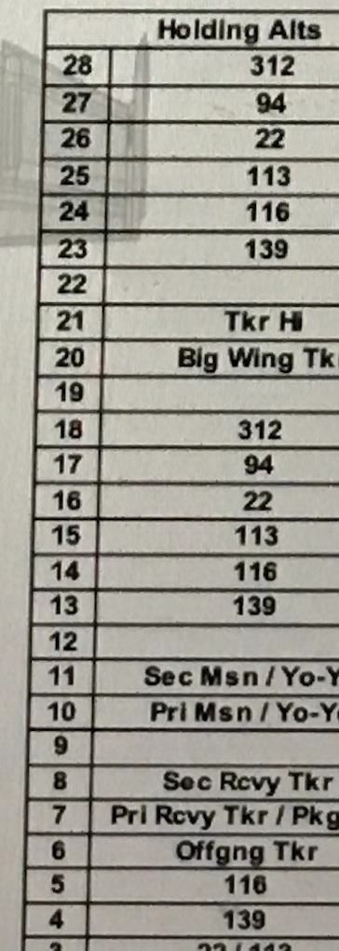
Taking the right image from a real-life carrier card as an example: It shows the VAQ-139 Growlers stack at angels 4 and the
VAW-116 Hawkeyes at angels 5. It also shows VFA-22 and VFA -113 sharing the stack altitude of angels 3. The lowest Stack altitude will be angels 2 and all levels will be separated by 1000ft.
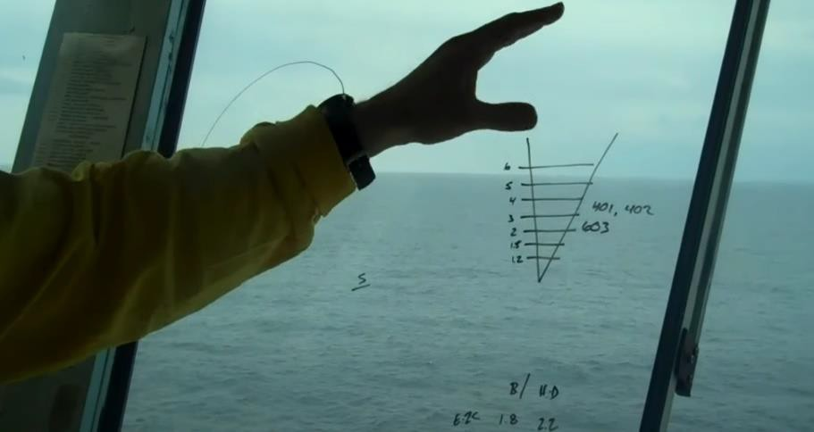

Let’s take this to a little more depth:

The case I marshal stack also known as port holding pattern. The Marshal stack is a left-hand pattern tangent to the BRC or expected BRC with the ship in the 3 o’clock position and a maximum diameter of 5 nm. Flights shall be established at their assigned port holding pattern altitude 10 nm prior to entering the pattern. Entry shall be tangential with wings level. Minimum altitude assignment shall be 2,000 feet MSL. A minimum of 1,000 feet vertical separation between holding altitudes shall be maintained. The squadron altitude assignments shall be as promulgated by ship/air wing doctrine. All aircraft shall maintain the prescribed separation and landing order in the port holding pattern and throughout the descent. Departure from the port holding pattern for break entry shall be
accomplished aft of the ship’s beam (“abaft”). Descent to the break from the port holding pattern is commenced by the lowest aircraft or flight in time to minimize “open deck time”. This descent should be planned to arrive at the initial (3 miles astern, 800 feet) wings level, paralleling the BRC.

So how does that look?
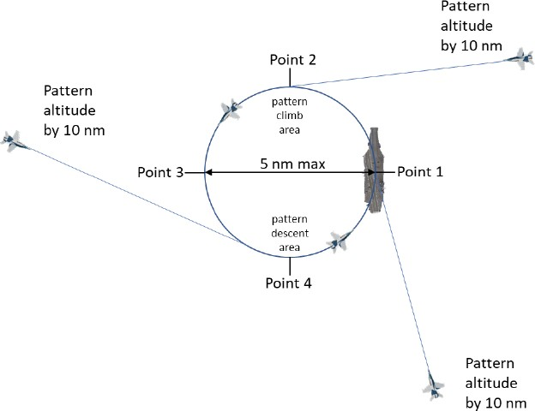

The Stack:
I will try to create a picture of how entering / flying / leaving marshal will look.
For that we will have to make some assumptions and I will try to explain the techniques in a little more depth along the way. Please note there are endless possible scenarios, and I am unable to describe them all, therefore I will try to cover the possibilities that give the most confusion in DCS.

For the following images we will use 4 different squadrons:
Sq. RED a division of 4 aircraft Sq. stack altitude is Angels 2
Sq. GREEN a flight of 2 aircraft Sq. stack altitude is Angels 2
Sq. BLUE a flight of 2 aircraft Sq. stack altitude is Angels 3 Sq. ORANGE also a flight of 2 aircraft. Sq. stack altitude is Angels 3

Entering the Marshal Pattern:

Entering the marshal stack is commonly done at point 1 or 3 but can be entered from any point tangentially on the circle. In the following example the RED division joins at point 1 and GREEN Flight joins at position 3.
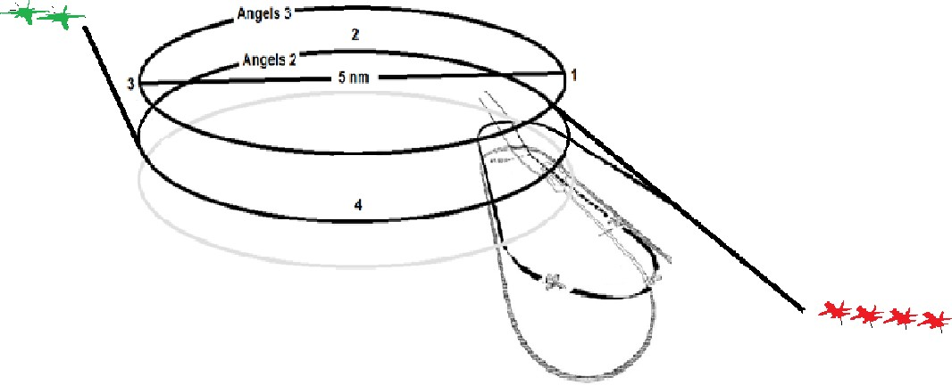

How many different flights can be at 1 stack altitude?

Typically, two squadrons occupy a single altitude, and they will occupy across the circle from each other. CV NATOPS does not limit the number of flights to two. However, two is the normal standard separated by 180 degrees offset in the pattern. The main reason is that everyone is expecting one or two flights per stack altitude, so when collapsing the stack, it would be unsafe to descend when an unknown third flight is out there. 99.99999% of the time, the naval aviation standard is one or two flights per altitude, even though CV NATOPS doesn’t specifically mention that.

So what if the RED squadron would be flying with more than 8 aircraft?

This simply does not happen. Usually there are 3-4 from each squadron in a cycle. Remember, the ship has its limitations. Also, remember the squadron would be active during multiple cycles at once. One group is airborne waiting to recover while another group is on deck launching. There is simply never a need to have that many from one squadron going. Finally, assume a squadron has ten jets. 7 is a strong average number that will be “up” at any time. Some older jet squadrons may only have 4 up at a time. But never are 100% of jets in an up status. Most squadrons these days have more than ten jets. But in rhino squadrons some are tanker configured, and usually they stay that way for a while rather than swapping back and forth frequently.

Another scenario: Let’s assume GREEN is NOT flying this cycle. However RED is flying with 2 Aircraft both scheduled for individual training or whatever the reason might be. We will call them RED 1 and RED 2

After the mission/training both individually return to the boat. RED 2 notices that RED 1 is already in the marshal stack at Angles 2. Would RED 2 be allowed to just cling on the wing of RED 1 and recover as a Flight of 2 or does RED 2 have to take its own place in the Marshal?

The answer as always is “it depends.” The first thing to note, as that each pilot in this situation would have looked at the airplan in the pre-flight preparation and knows what the recovery will look like. The next thing to note is if one pilot is a qualified section lead or not.

So, you would either precoordinate coming into the break together (so long as one was qualified as a lead), or you could do the more interesting thing to join up on him in the stack (again, since you know he is a lead). 9 times out of 10, the two would discuss the idea before going flying, rather than just joining.

What If RED 2 sees his mates from the BLUE squadron and likes to join up with them?

In the case of different squadrons, it will get a bit more interesting and fun. It isn’t common but yes, pilots will find a “lead of opportunity” in the stack and join on them. This lead may or may not be a qualified lead, and sometimes a nonlead can end up leading someone into the break (or a section lead but not division lead, leading a 3/4 ship into the break). Again, this is not common. But just finding a lead to join on does happen once in a rare occasion.

If you were a junior pilot going flying as a single ship, and you felt more comfortable going back with somebody else, 99% of the time you would look at the airplan, look at what squadrons were flying, stop by their ready room and ask if you could join them for the recovery.

What if RED and GREEN are entering the marshal, but the 2nd flight entering finds itself not at the ideal 180-degree offset position of the other.
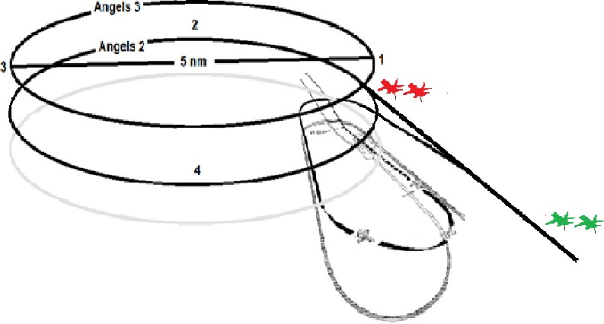

Fighter pilots have learned and developed a skill of creating great situational awareness and have the ability to quickly and effectively position themselves in such a way that a good separation will be met when entering the marshal stack. The SA page, A/A Radar, TGP and HMD can all add to create this awareness. Pilots/Flight leads will play out the way they join the circle to make the geometry work. If GREEN however would find itself not in the ideal position when entering marshal, SPEED and GEOMETRY will be used to place themselves in that position. Whether that means a slightly wider entry, a lower speed on entry etc.

Now event 2 Launch is in progress and the event 2 recovery aircraft have met in the Stack 10 to 15 minutes before event 2 launch is expected to finish. Again this information will all be obtained in the airplan. For this example we will asume that 4 separate regular squadrons from event 1 are in the marshal stack at angels 2 and 3 and they will recover in event 2.
For the following images we will use 4 different squadrons:
Sq. RED a division of 4 aircraft Sq. stack altitude is Angels 2
Sq. GREEN a flight of 2 aircraft Sq. stack altitude is Angels 2
Sq. BLUE a flight of 2 aircraft Sq. stack altitude is Angels 3 Sq. ORANGE also a flight of 2 aircraft. Sq. stack altitude is Angels 3
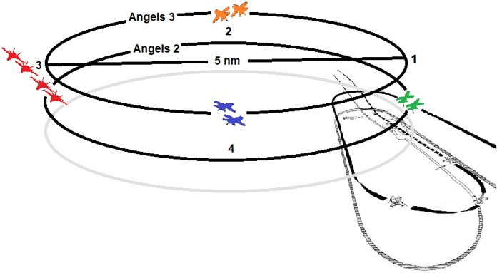

The lead aircraft is always looking below. Remember, the event 2 launch comes first, and then the event 2 recovery.

The aircraft at 2000 feet have the glory and privilege of “breaking the deck,” meaning they are the first ones down (particularly, the first element down from 2k as there is typically more than one). The aircraft at 3000 feet are looking down at the ones at 2000, and the ones at
4000…..and so on.

The aircraft at 2000 are looking to commence automatically when they determine that they will be in the groove with a clear deck. THIS IS AN ART! Depending on where you are on the circle, and how many are left to launch, it is up to you to play this out.

For example:
If you are overhead the ship and you see there are 3 jets left to launch on the waist catapults, you decide then that you want to commence. Then as you go into the break and you’re overhead the ship, you see the deck is slow and there’s still 2 jets to launch, so now you extend further upwind before you break. THE IDEA IS TO ROLL INTO THE GROOVE WHEN THE DECK GOES CLEAR FROM THE
LAUNCH. IRL, this means after the deck crew have “wrapped the waist” and covered the catapults after the last jet launched, and then run clear of the landing area. The other jet(s) at 2k follow the first element. The jets at 3k now commence down to 2k, and the jets at 3k…and so on. The jets at 2000 "break” the deck. The jets above that “collapse the stack.”

If done perfectly, every single airplane will commence and be spaced out evenly to land 45 seconds apart from each other. The Recovery Tanker will be the last one aboard as he has nobody to take care of anymore. Although for simplicity sake the Recovery tanker is not drawn in the following images.

In the image below we will assume that the RED squadron will be breaking the deck. They will descend out of position 3 and VISUALLY determine the status of the deck to put themselves in the ideal position to arrive in the groove when de deck goes clear from the launch.
As previously mentioned, If you are overhead the ship and you see there are 3 jets left to launch on the waist catapults, you decide then that you want to commence. Then as you go into the break and you are overhead the ship, you see the deck is slow and there’s still 2 jets to launch, so now you extend further upwind before you break.
Remember descends are only allowed on the stern side of the ship (“abaft”), though most commonly
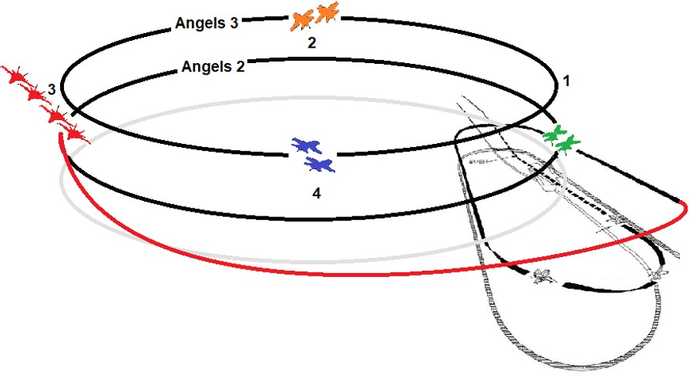
at point 3.

As RED starts to commence GREEN will follow, being the next group in sequence at angels 2. Speed and geometry are used to close the gap to the RED flight. In this particlar case GREEN flys a tighter pattern and uses speed to its advantage. There are many different ways to make this possible.
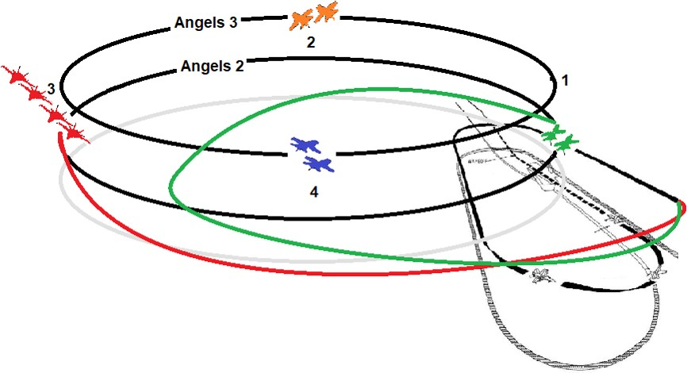
CV NATOPS does not describe a set technique regarding how you must proceed from “commencing” to “the initial”. This would make it impossible for aircraft to position themselves ideally when things are even the slightest outside the ideal scenario. Green therefore can use SPEED and GEOMETRY to their advantage as seen above. HOWEVER, they are NOT allowed to descend on the bow side of the marshal stack and therefore must maintain level flight until reaching position 3.

It is however NOT allowed for GREEN to cut the corner right over the ship to catch up the aircraft ahead of them. There is some tolerance for tightening the circle to a smaller diameter than 5 miles if needed, but what GREEN has done here is too extreme.

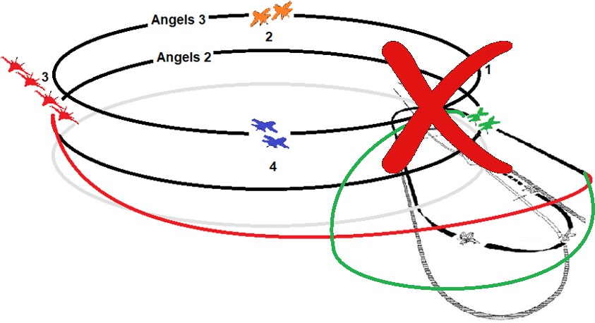

Whilst a tight “initial” could be a flow, a 1 or 2 mile “initial” would not be acceptable. Please see the
example below.

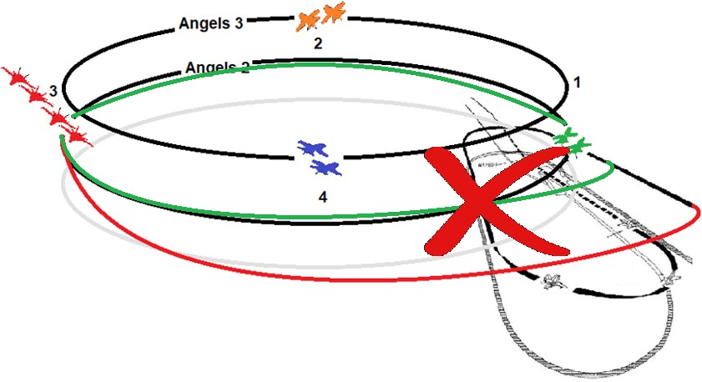

As BLUE and ORANGE, see RED and GREEN start to commence, they will now make the stack collapse.
ORANGE finds itself on the bow side of the stack, so will have to wait until position 3, before it can start to descend. BLUE finds itself on the stern side of the marshal stack and can therefore descend right away but will have to be level at 2000ft before reaching position 1.

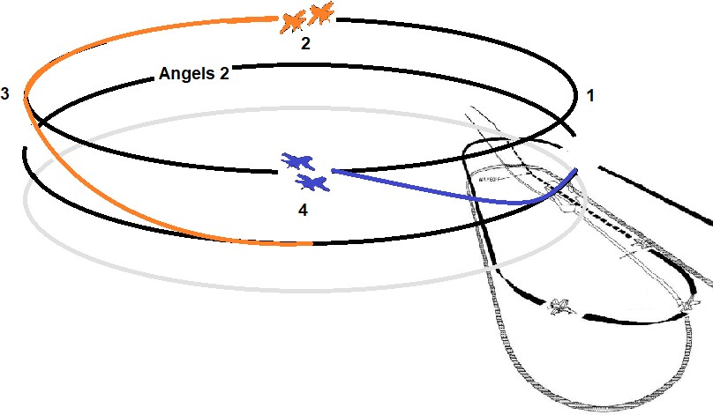

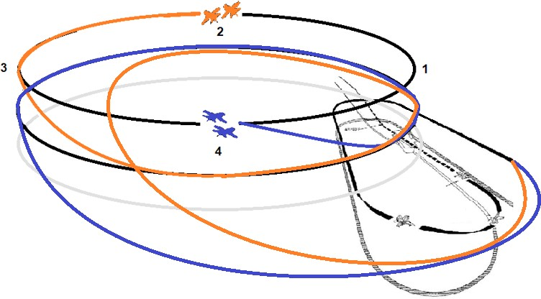

So how would that look in its entirely:

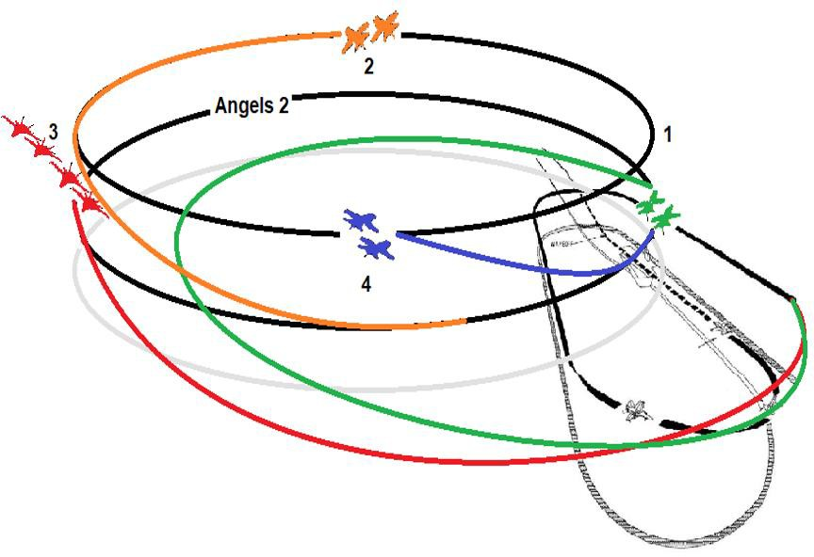

Now can RED split the division into 2 separate sections when commencing by letting the first 2 accelerate and fly a tight pattern, whilst the 3 and 4 delay the acceleration and fly a wider pattern?

This is not a thing. The idea is that whatever formation you are in the stack, is the formation you go into the break. If not doing so, it would be impossible for GREEN to predict their progress and their actions.

How do you make sure the division would all stay within the 4nm limit on the bowside of the ship, if all are flying 350 knots with the standard 17 sec intervals (lead breaks at 0 nm, 00:00 and #4 breaks at 00:51): 4.60 nm DME. How do you prevent this?

The lead of a division (4 aircraft) will normally break aft of the bow of the ship. Breaking aft of the
ship’s bow will be required to keep all wingmen inside of 4 nm.

But what if Lead cannot break aft of the bow because there are already aircraft in the pattern?

First of all, remember, the maximum number of aircraft in the pattern at one time is 6. The lead will therefore break with his correct interval wherever that may be, and some of the aircraft might have to enter the spin pattern. This all depends on where other aircraft find themselves in the pattern at that moment in time. If the pattern is full or nearly full, any number of aircraft may have to spin

Additionally, a division will not typically recover from above angels 2 They would split into sections before reaching the marshal.

It is important to realize there is a lot of deal making on the ship. A lot of going to ready rooms, shaking hands, asking if I could join at angels 2, asking if we could combine sections to a division, asking if I could take the vacant spot at angels 3 instead of angels 4, etc. Airplan study, seeing what you want to do, and then figuring it out in preflight on the ship will help determine what the final recovery may look like. To be clear, those negotiations and deals do not happen every recovery. But it happens often enough.

THE PATTERN FROM ABOVE:

For the folling examples we will use 3 different squadrons:
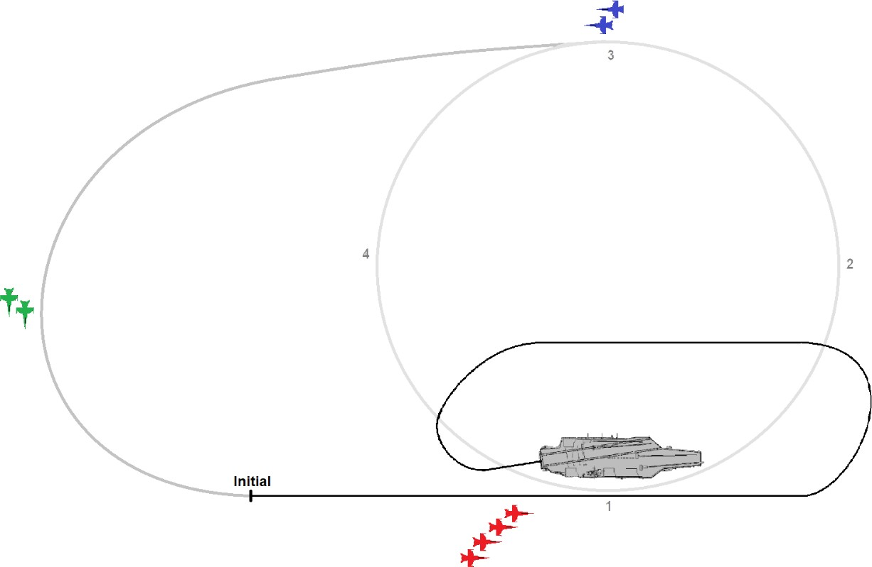
Sq. RED a division of 4 aircraft
Sq. GREEN a flight of 2 aircraft Sq. BLUE a flight of 2 aircraft

When entering the pattern there is one big question you have to ask yourself: “WHERE AM I IN RELATION TO THE GUY AHEAD?” This is otherwise known as: “Where is my interval?” This will determine your next actions in the pattern.

Break interval:
When to break is determined by the last aircraft in the landing pattern as they have priority, and the amount of aircraft in the flight.

If you lead a division (4 aircraft) into the break you will need to break aft of the bow of the
ship. Breaking aft of the ship’s bow will be required to keep all wingmen inside of 4 nm.

- If entering the break as a wingman, start the break 17 seconds after the preceding aircraft. A 17 second break interval will correspond to a 45-60 second landing interval.

- If entering the break as a single ship, or as the flight lead, then start the break when your interval passes behind your stabiliser and is out of sight.

- If entering the break as a single ship, or as the flight lead, and the pattern is empty, then the break is at your discretion (during cyclic ops, break as soon as comfortable to minimize
“open deck time”).

It is important to be aware of the following:

*** There’s never an expectation for the lead to break aft of the bow *** unless bringing in a division, or you are late breaking the deck. In the case of being late breaking the deck, if an inexperienced or nonproficient pilot is the one breaking the deck, it is understood if he/she does not break aft of the ship, and he were to break a mile upwind.

We will start with the Ideal Scenario where aircraft will not bolter, and all fly a perfect pattern.

RED 1 breaks at the stern of the ship.
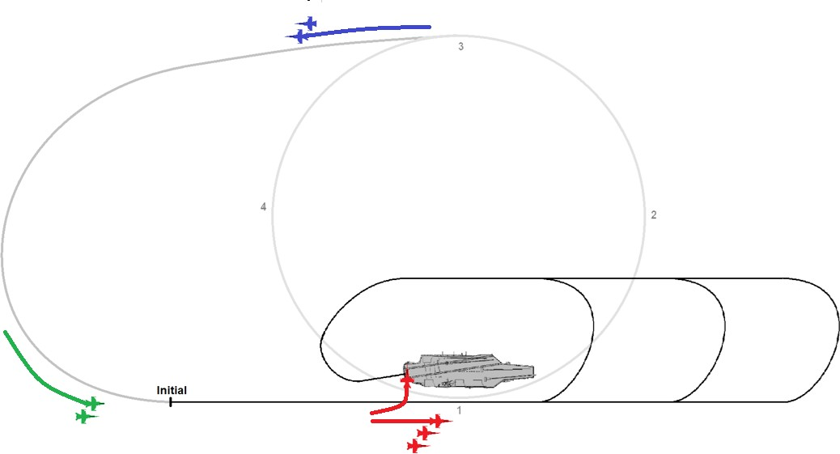

RED 2 breaks 17 seconds after the lead, whilst the GREEN flight reaches the initial and the BLUE flight has commenced.

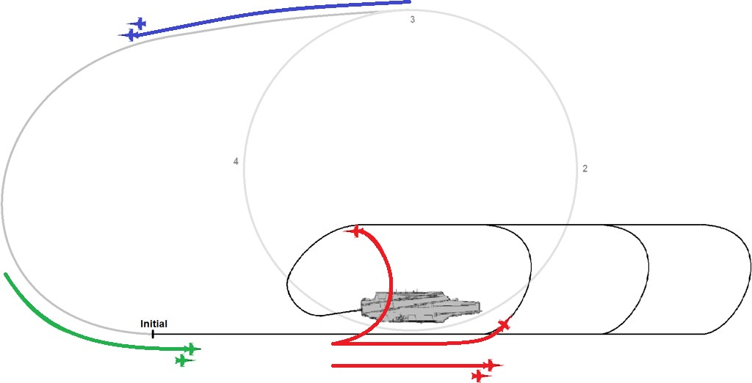

RED 3 now breaks 17 seconds after RED 2 whilst GREEN has passed the Initial and BLUE is descending towards the Initial.

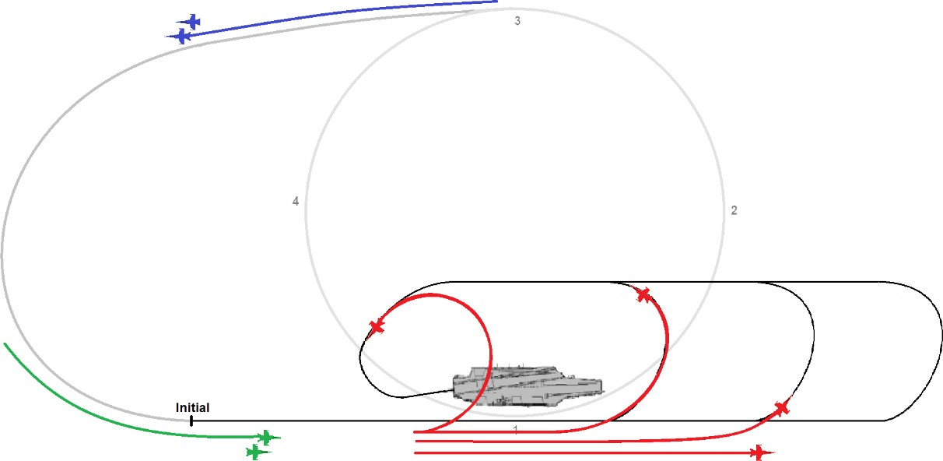

RED 4 now breaks 17 seconds after RED 3 whilst GREEN is approaching the Stern of the boat. BLUE is getting closer to the initial. Very important to note is RED 2 is at the 180 whilst RED 1 is approaching the stern of the boat known as “in close” or IC. This is an indication to RED 2 that he/she is on a correct interval.

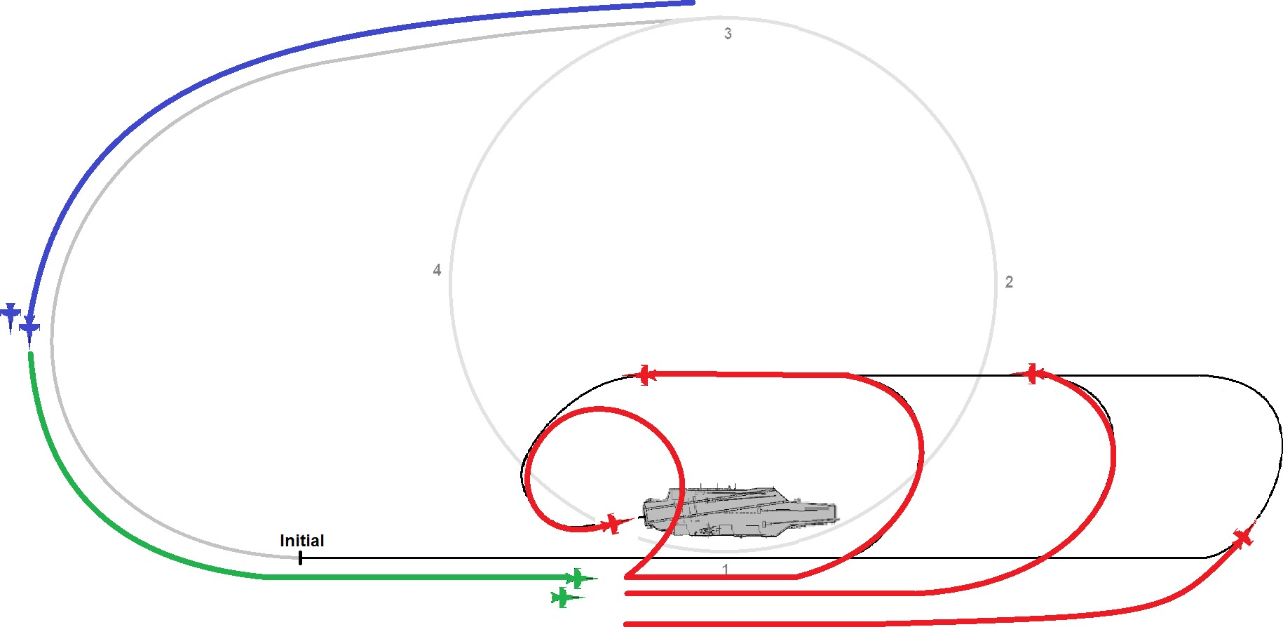

Slowly things are getting a little more interesting. About 6 aircraft are in the pattern and remember that is the maximum number in the pattern at one time. On the other hand, RED 1 is about to touch down and assuming he/she does not bolter or waveoff things are looking good.

Now for the GREEN flight the same question comes into play: “WHERE AM I IN RELATION TO THE GUY AHEAD?”

The GREEN flight approaches the bow of the ship and sees RED 4 in the pattern. RED 4 in this case
is “the interval” for the GREEN flight.

Remember talking about break interval? The following rules come in effect for the GREEN flight.

- If entering the break as a single ship, or as the flight lead, then start the break when your interval passes behind your stabiliser and is out of sight.
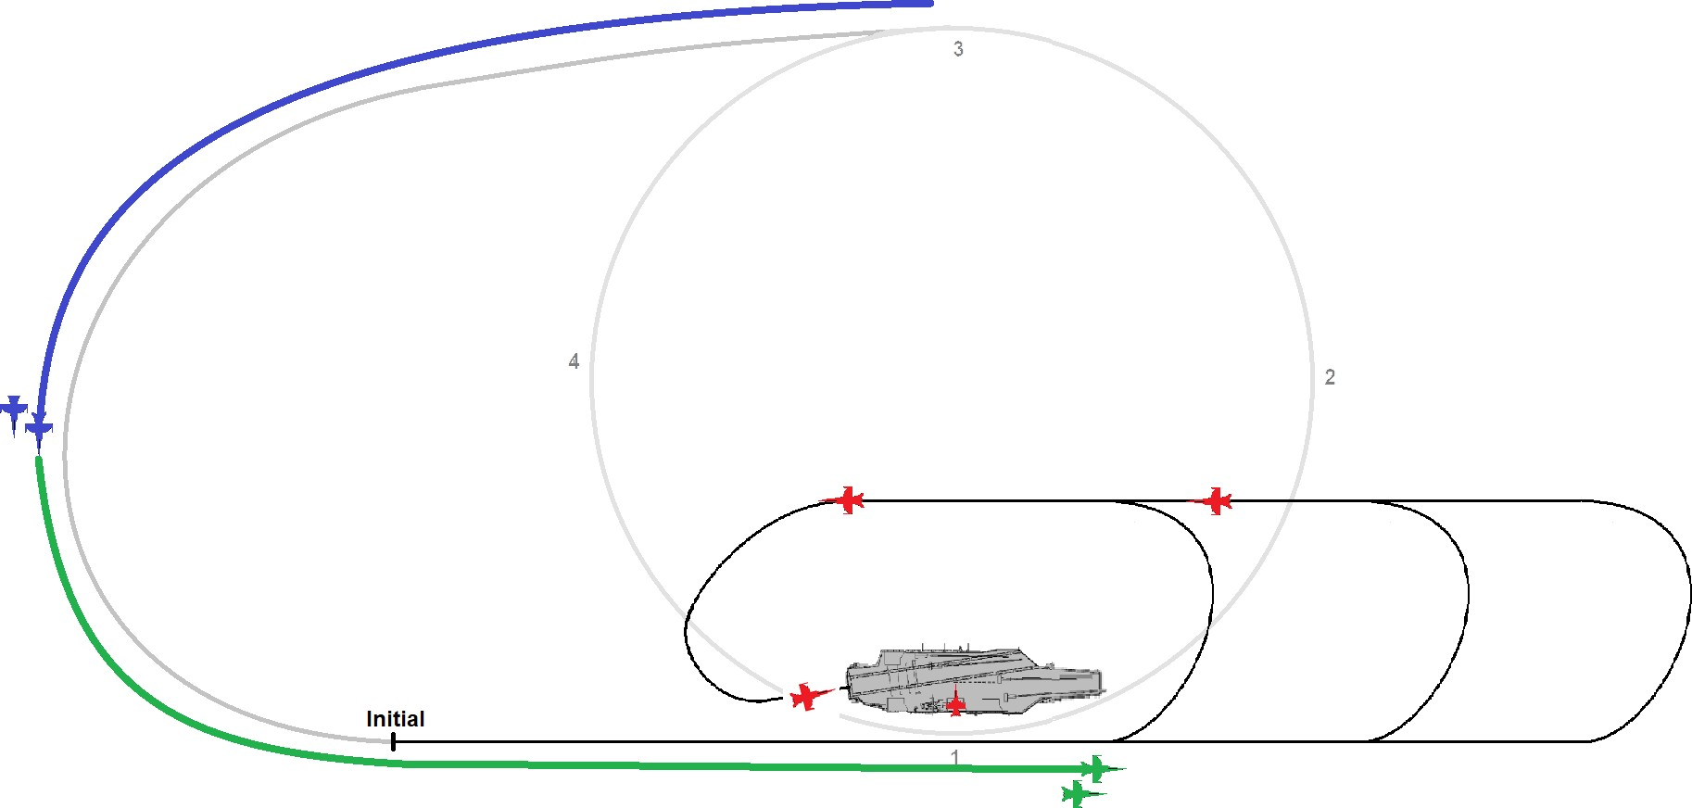

GREEN 1 waits until RED 4 is passed its stabiliser and is out of sight, before entering the break.
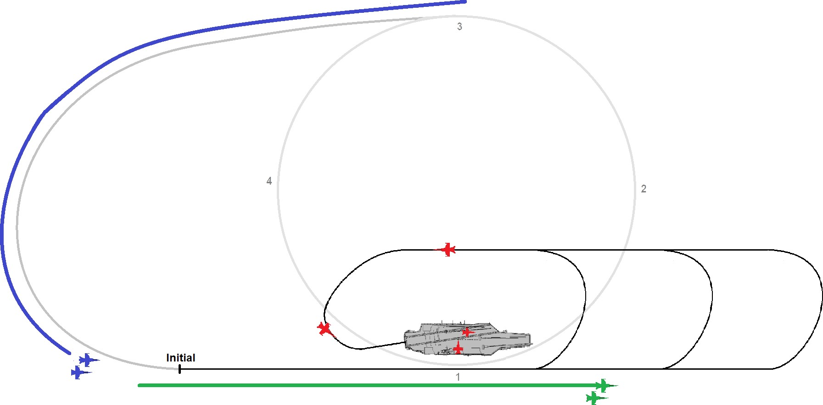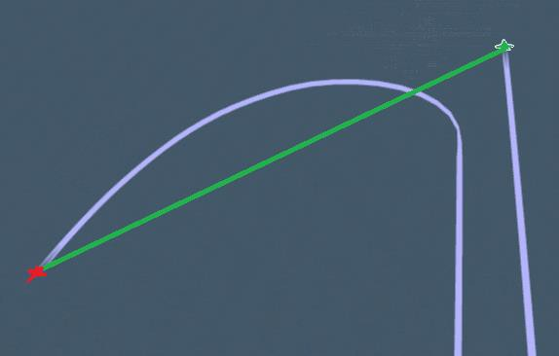

GREEN 2 will break 17 seconds after GREEN 1. BLUE will follow the exact same sequency where BLUE 1 will break when GREEN 2 passes behind its stabiliser and disappears out of sight. BLUE 2 will break 17 seconds after BLUE 1 and all aircraft should be ending up safely on deck.

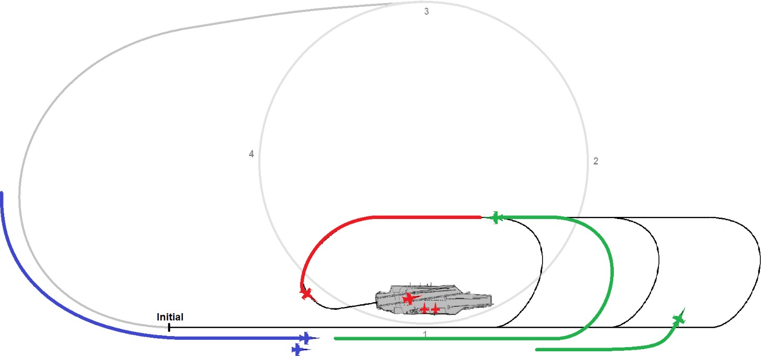

Bolter/Waveoff or Touch-and-go scenarios:
Let’s have a look at Bolter/Waveoff scenarios and who will get priority.

Upwind interval is determined by “first to the bow”, whether that is break traffic, waveoff, touch- and-go, or bolter. Once upwind, the proper interval to follow traffic on downwind is to wait until they reach your 7 o'clock position, (visually when the traffic reaches your left horizontal stabiliser).

As RED is the aircraft performing a Bolter/Waveoff manoeuvre he will be turning to the BRC, climb to 600ft and turn to downwind with his interval. As in this case the GREEN flight is reaching the bow first, GREEN will break to downwind. GREEN 2 will turn to downwind 17 seconds later and RED will follow GREEN 2 when GREEN 2 is at it’s 7 o'clock position, or when the GREEN 2 reaches its left horizontal stabiliser and disappears out of sight.
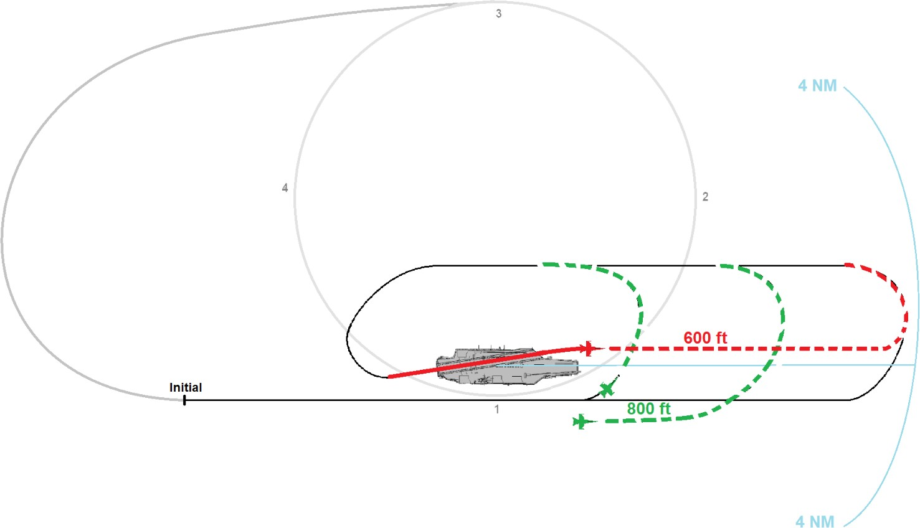

If however RED is unable to execute its turn back to downwind before reaching 4nm upwind of the boat, then RED will have to depart the pattern and re-enter.

In the following scenario RED is again the aircraft performing a Bolter/Waveoff manoeuvre and he will be turning to the BRC, climb to 600ft and turn to downwind with his interval. However, this time it is RED reaching the bow first, and therefore GREEN 1 will have to wait until RED passes its 7 o’clock position or visually when RED reaches the left horizontal stabiliser and disappears out of sight.
GREEN 2 will break 17 seconds after GREEN 1.
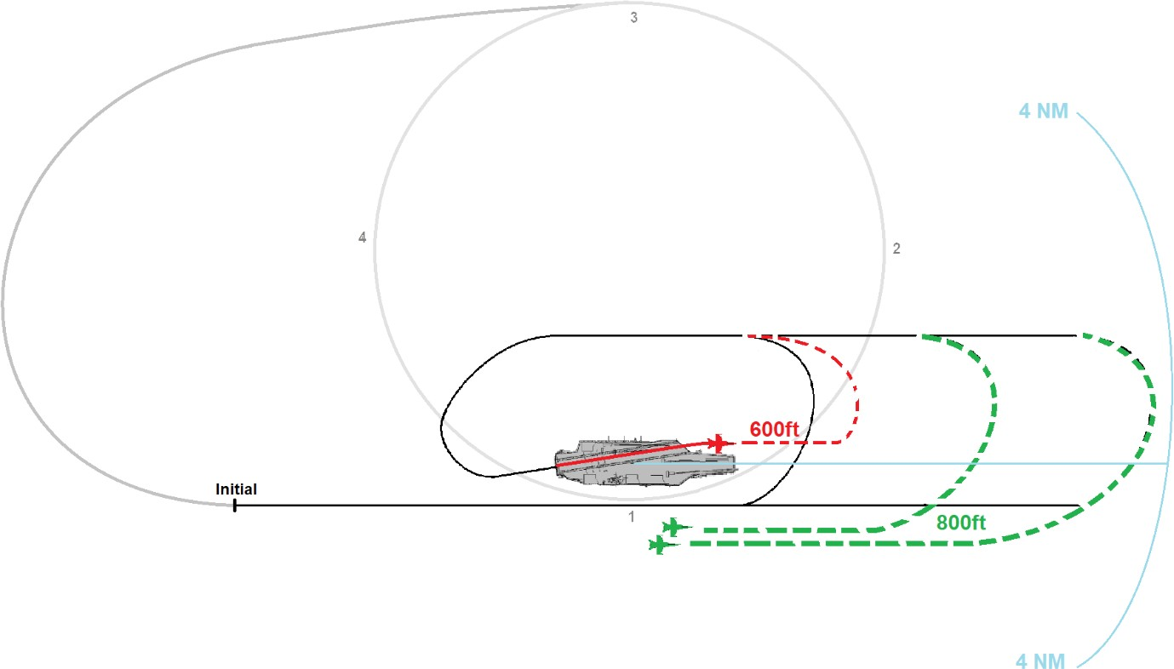

If however GREEN 2 is unable to turn to downwind before reaching 4nm upwind of the carrier, then
GREEN 2 will have to depart the pattern and re-enter.

SPIN pattern:
What exactly is a spin, what does the pattern look like, and when is it normally initiated?

View a “spin” as an expedited way to send you back in the landing pattern without going back into
the marshal stack again.

Spin mechanics:
If the pattern is full (more than six aircraft in the pattern) when the flight arrives at the fantail, the flight will have to “spin it”. To perform a spin: at the bow the flight will simultaneously climb to 1,200ft AGL and perform a left-hand turn remaining within 3 nm. The speed will remain at 350 knots, (yes this is a sporty turn to remain withing 3 nm). The maximum number of 6 aircraft may be modified by the air officer (“Boss”).

Pilots must exercise caution to avoid departing aircraft, but prior to entering the landing pattern, aircraft shall climb or descend as required and enter the spin pattern (1,200ft AGL) unless specifically directed otherwise.

Aircraft in the landing pattern shall continue to maintain proper interval, flying the landing pattern at 600ft AGL until otherwise directed. Flights directed to spin or re-enter the port holding pattern shall climb only on the upwind or crosswind leg ahead of the ship’s abeam. *Aircraft re-entering the break from the spin pattern have priority over aircraft entering from the port holding pattern.*

After 270 degrees of turn (aft of abeam, or "abaft"), the flight will descend to 800ft AGL and proceed inbound for the break. Aircraft re-entering the break from the spin pattern have priority in the break. Upwind interval is determined by “first to the bow”, whether that is break traffic, waveoff, touch- and-go, or bolter traffic. However, caution must be exercised when re-entering the initial so as to avoid conflict with other aircraft inbound for the break. A spin should normally be initiated at the bow.

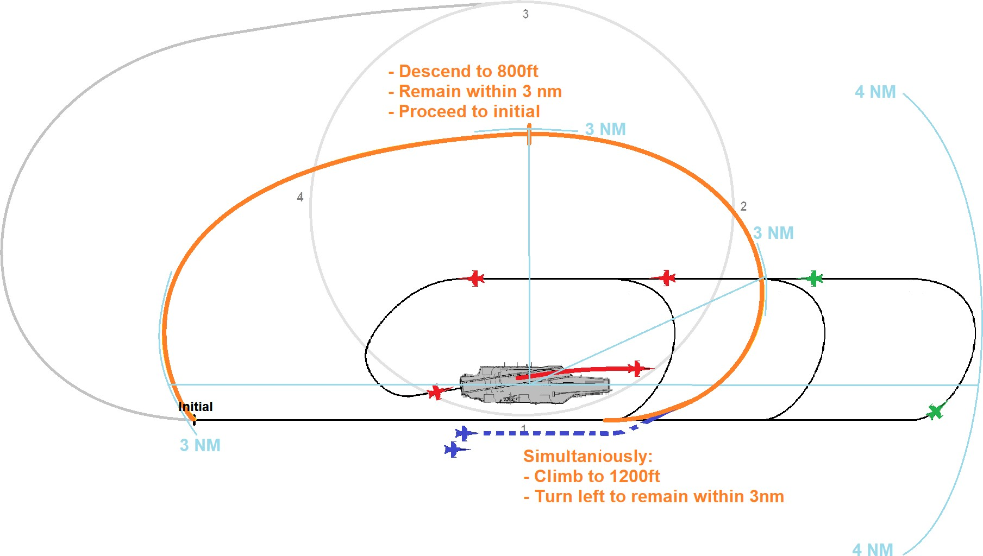

Depart and re-enter:
It is important to understand that "depart and re-enter" is not the same as the flying the spin pattern.

Depart and re-enter simply means go away and get back to the initial.

An aircraft might be told to depart and re-enter from any position and no specified procedures are provided to describe how it is to be flown.

If an aircraft is unable to execute the break before 4 nm upwind, they will then have to depart and
re-enter. To accomplish this, any technique is allowed as long as they remain clear of the pattern and the stack (even right turns would be legal, although uncommon). If told to depart and re-enter, specific instructions might be given on how to do this. If no instructions given, then notify Tower of your intentions.

Note: No single pattern can be drawn for a depart and re-enter event as there are endless possibilities.
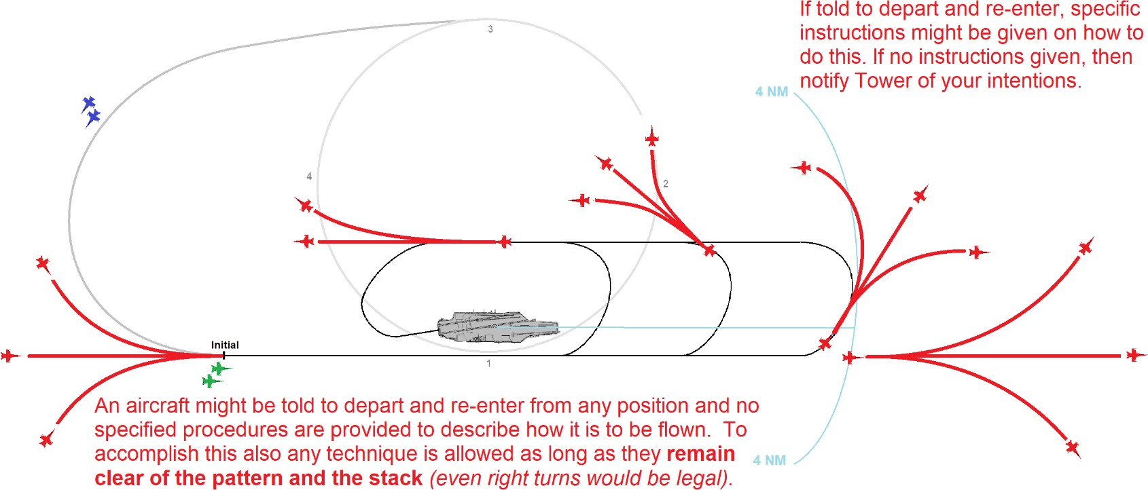

NOTE:

Endless scenarios are possible, not only in “The Stack”, “The Pattern” but also in case of an aircraft performing a “Bolter, Waveoff, Touch-and-go” manoeuvre, an aircraft being told to “Depart and Re-enter” or even “The Pattern”
being full and an aircraft having to “Spin”.

Therefore take the sketched images as possible scenarios, whilst more or multiple options might be available that will also lead to a legal and safe outcome of cyclic ops. ***REMEMBER: No two Case 1 recoveries have ever been the same!***

Many thanks for taking the time to read this, and as always feedback will be appreciated.

