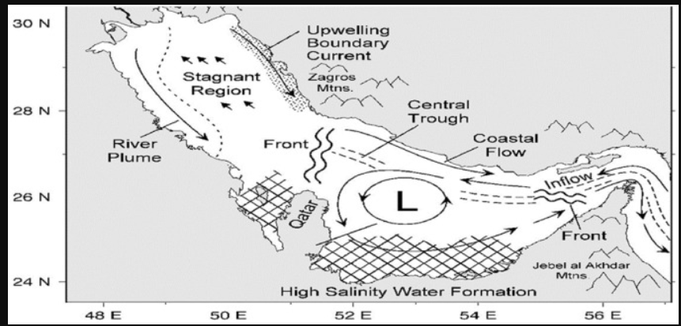
Source of graphic: https://ars.els-cdn.com/content/image/1-s2.0-S2468013320300115-gr9.jpg

