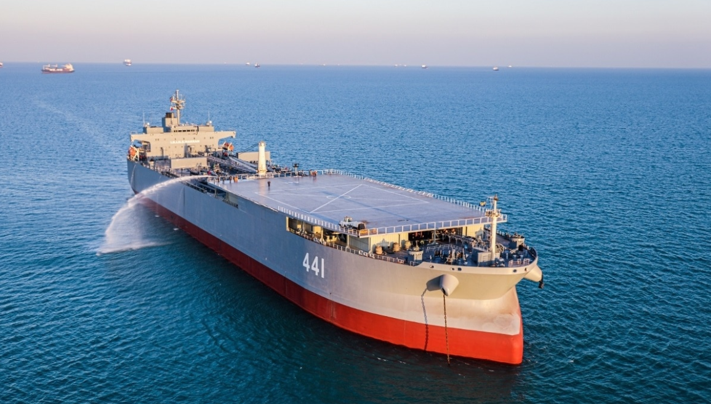
This is a photo of Iran’s warship called IRINS Makran. It is a converted oil tanker turned helicopter landing pad ship.
Source of information: https://www.19fortyfive.com/2021/07/irans-largest-warship-might-not-actually-be-a-warship-after-all/

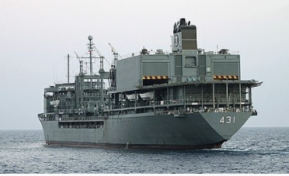
This is the Irian Forward Base Operating Ship that sank in the Persian Gulf last year. It had helicopter hangers and could supply ships at sea.
Here is information about the IRIS Kharg: https://en.wikipedia.org/wiki/IRIS_Kharg#:~:text=The%20IRIS%20Kharg%20(Persian%3A%20%D8%AE%D8%A7%D8%B1%DA%AF,Navy%2C%20named%20after%20Kharg%20Island.&text=On%202%20June%202021%2C%20Kharg,in%20the%20Gulf%20of%20Oman.

