Screenshot 1 – after UNCAGE FOV is wide with no bracket/frame symbology incorrectly:
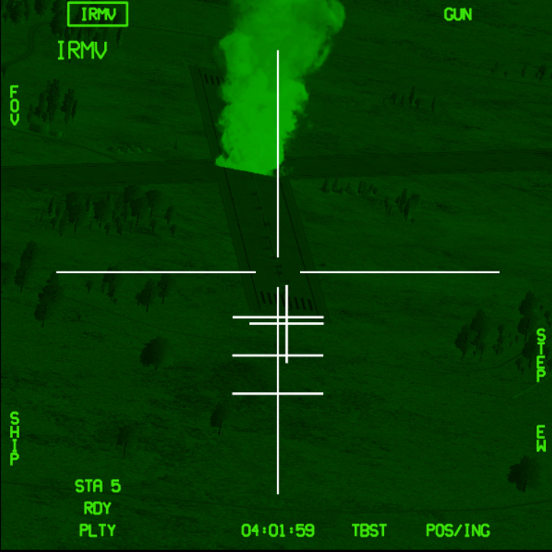

Screenshot 2 – 2 seconds later after Uncage, observe the FOV is now in narrow.
