Suggestions for Natural Disasters for Afghanistan Map
Approximately December 2021, I remember seeing DCS’s 2022 video. Coordinates showed a military base located in Afghanistan. It is my hope that either ED or one of their contractors produces an Afghanistan map.
The graphics shows the likelihood for various types of natural disasters such as flash floods, earthquakes, droughts. Some other common occurrences are avalanches and landslides.
The developers can use this information as inspiration to accurately reflect real-world information that could permit mission or campaign creators to add natural disasters.
I found this online information about natural disasters in Afghanistan. Here is the link: https://sesricdiag.blob.core.windows.net/sesric-site-blob/files/article/575.pdf#:~:text=%EE%80%80Afghanistan%EE%80%81%20is%20a%20landlocked%20country%2C%20which%20is%20recurrently,causing%20major%20losses%20to%20lives%2C%20livelihoods%20and%20property.
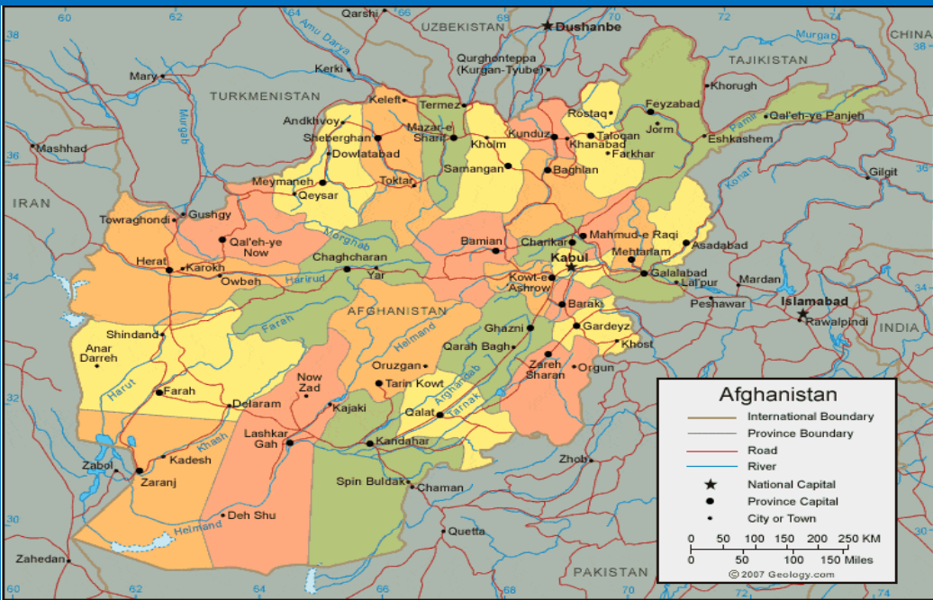
This map of Afghanistan is found on page 3.
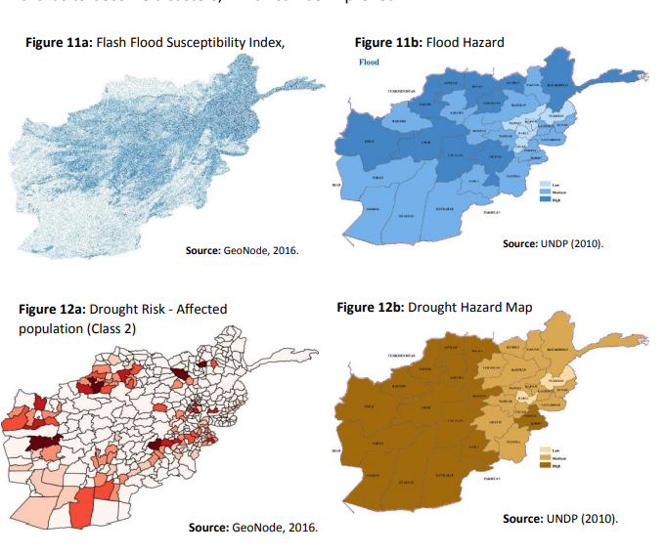
This graphic is found on page 17.
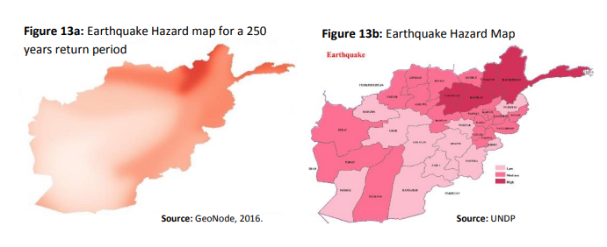
This graphic is found on page 18.

