Requests for DCS Enhancements
Recently, ED improved the weather by giving us more realistic clouds. I am making requests to continue weather improvements and weather modeling for aircraft on airfields covered in ice, snow, or rain.
Modeling Tire Spray on Taxiways and Runways
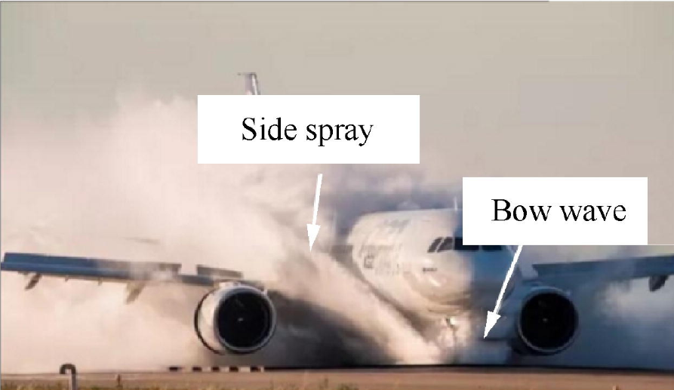
The photo shows a modern jetliner covered by weather, which generates significant water spray. Currently, ED does not model water spray on the airfields. Please add water ponding and water spray to the airfields.

Snow and Ice on Airfield
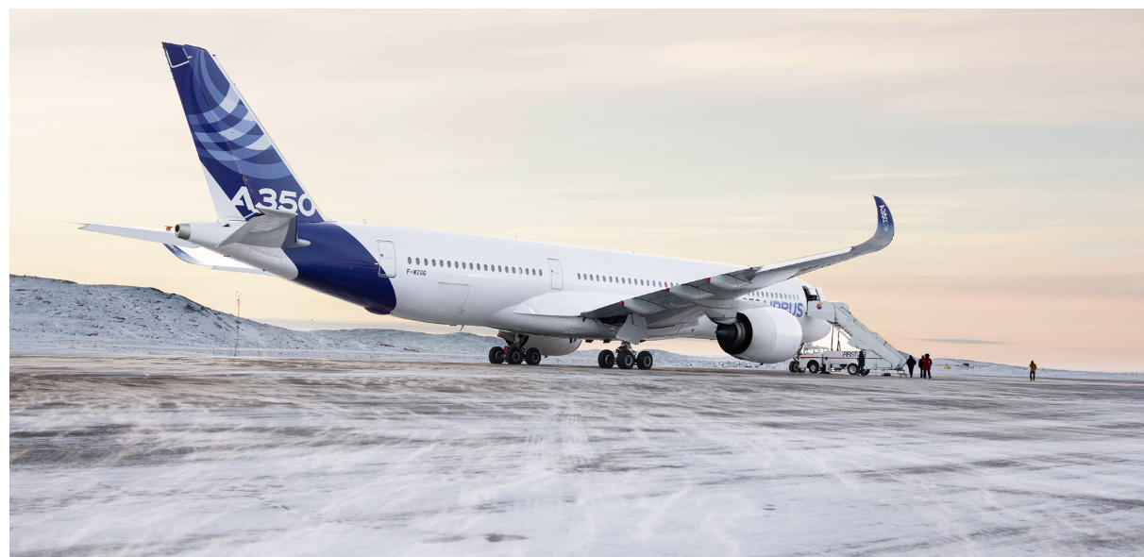
Photo of passenger jet on an icy and snow tarmac. Please add ice and snow to the airfield. Additionally, add the ability for the plane’s tires to slide on ice and snow.
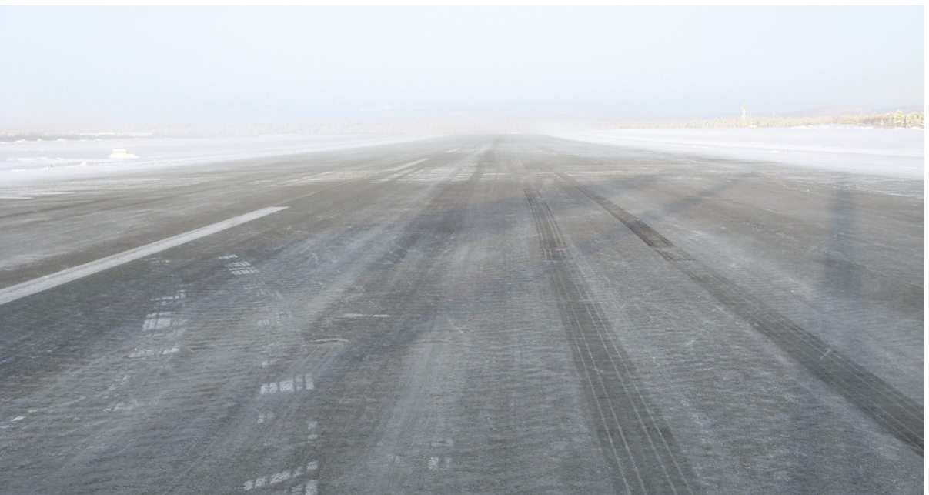
Image shows planes’ tire tracks on an untreated taxiway. Please add the ability for planes to leave tire tracks on snowy airfields.
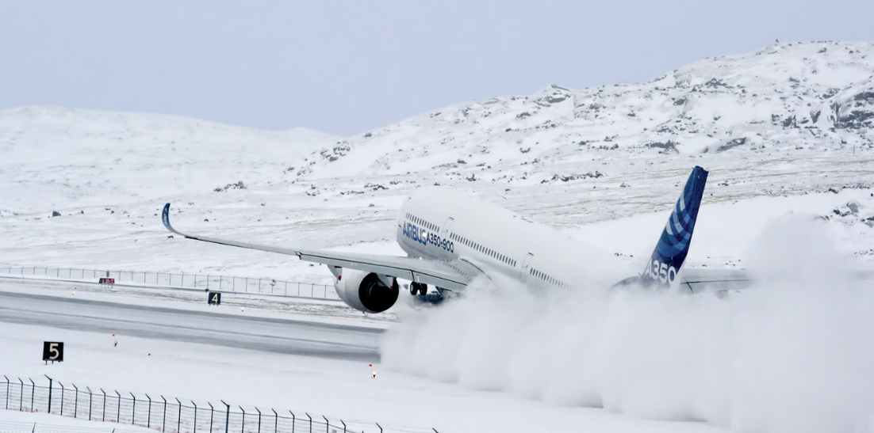
Photo of jet taking off on a snowy runway. Please model the blown snow effects when jets take off. Arrow points to blown snow caused by jet’s turbulence.

Slush
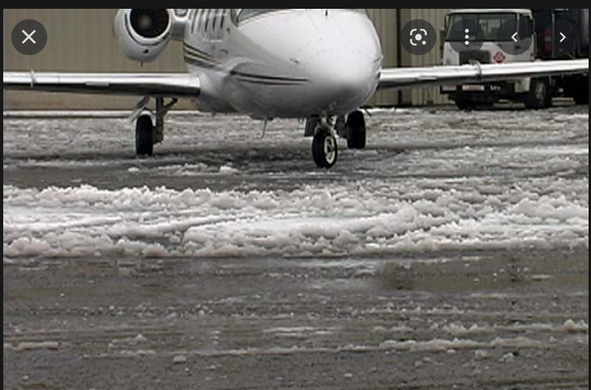
Photo shows slush on an airfield, which is likely a privately owned airport. Please model slush in the DCS software. Arrow points to slush.

Video of Propeller Plane Taking Off on Slushy Runway
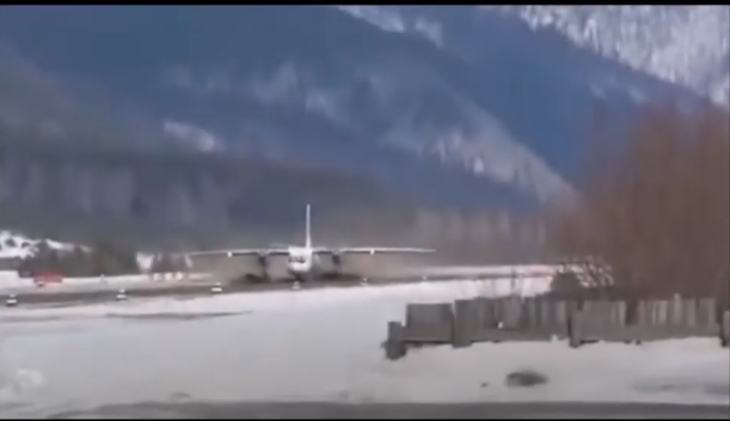
Here is the link to a short video showing a propeller plane taking off on a slushy runway at this URL: https://www.youtube.com/watch?v=wCiQIZtr-EE

