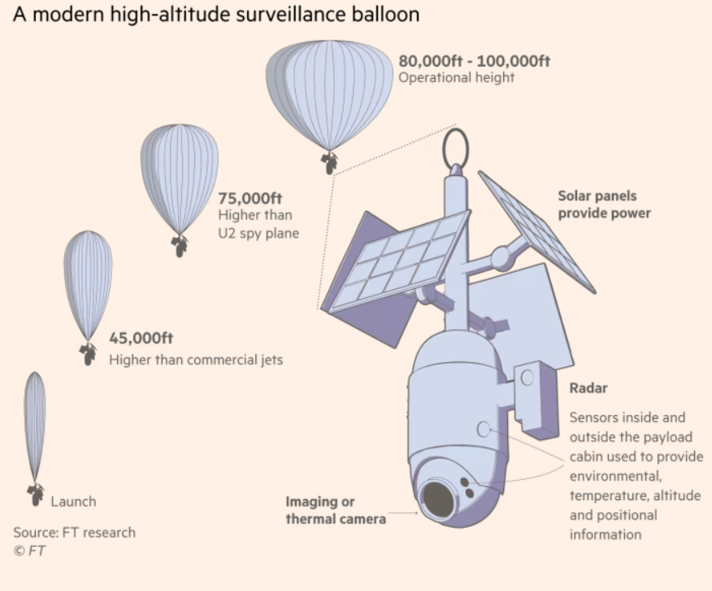
Graphic showing information about the Chinese spy balloon that crossed America.
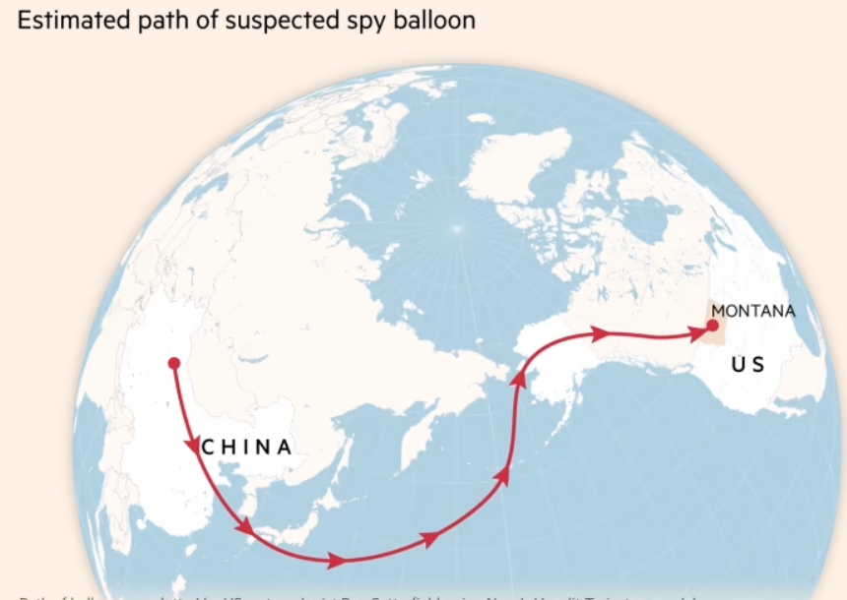
The graphic shows the estimated path the Chinese spy balloon flew from China to the United States.
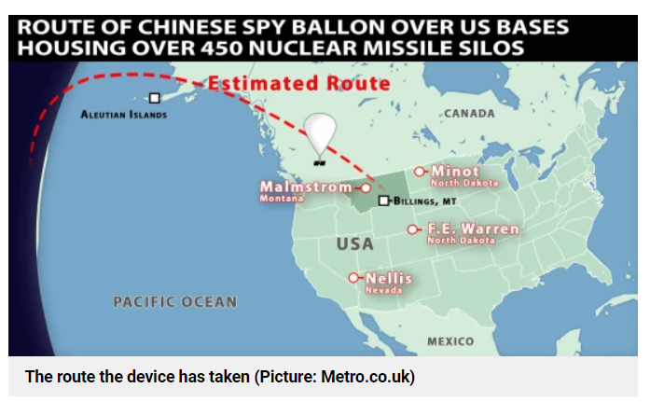
The image shows a projected path the Chinese spy balloon flew would cross in the United States. They were likely going across locations that have ICBM missile silos.
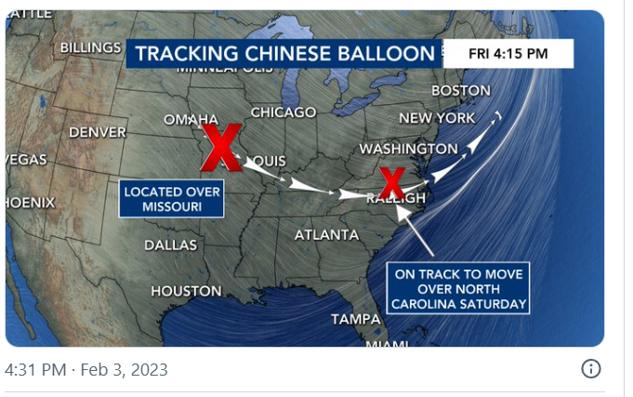
Another image that shows the Chinese spy balloon’s path as it flew further across America.
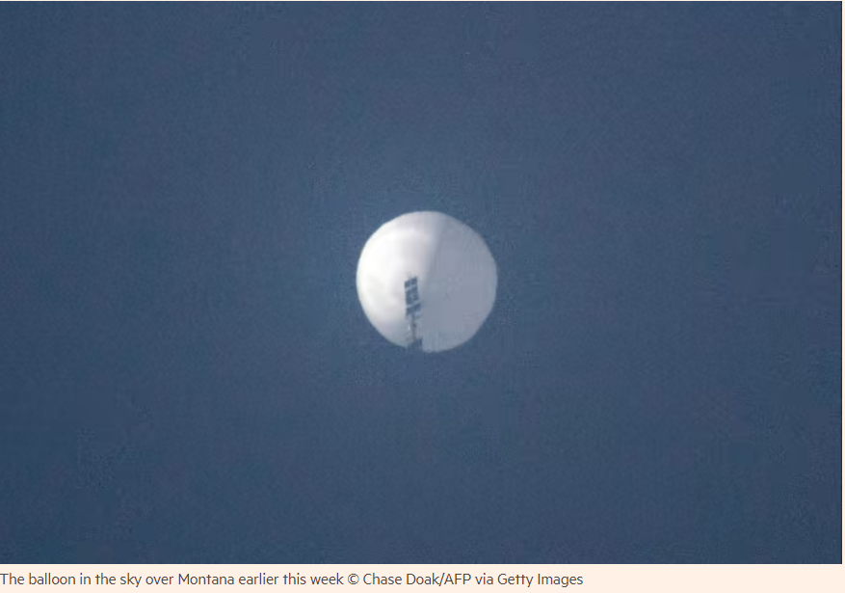
Real-world photo showing the Chinese spy balloon as it passed over Montana.
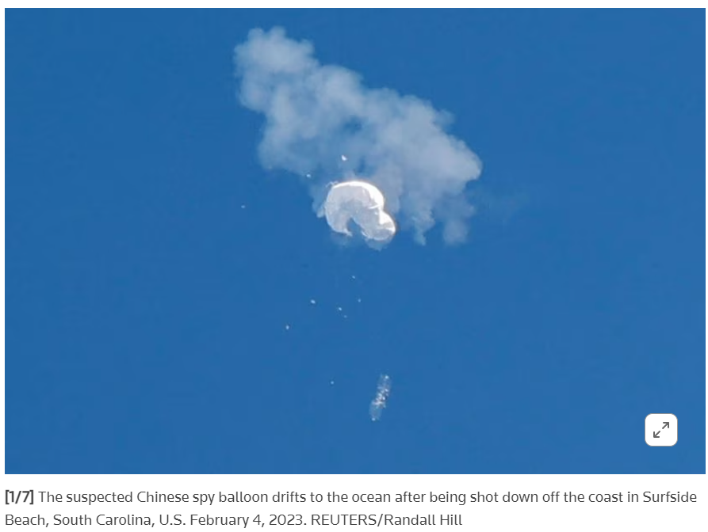
The photo shows the Chinese spy balloon shot down off the coast of South Carolina in the Atlantic Ocean.

