Phenomenon: As described in following
- Shake kit occasionally disconnected, SIMAPP freezes, and no signal output on X and Y axes of the base.
- The joystick is occasionally disconnected, SIMAPP freezes, and no signal output on X and Y axes of the base, and Windows plays the warning sound of device connected and disconnected continually.

Reason: Cables connecting the shake kit and the joystick or attaching to the joystick and the base became loose, resulting in poor contact.

Solution:
- Please re-plug the cable between joystick and the base and check if the issue is resolved.
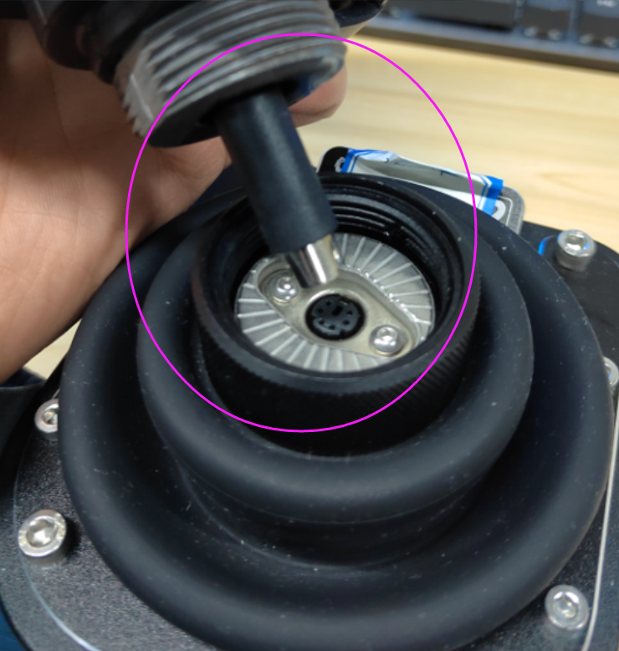
- Please reconnect the cable between shake kit and the joystick or change a spare cable and check if the issue is resolved.
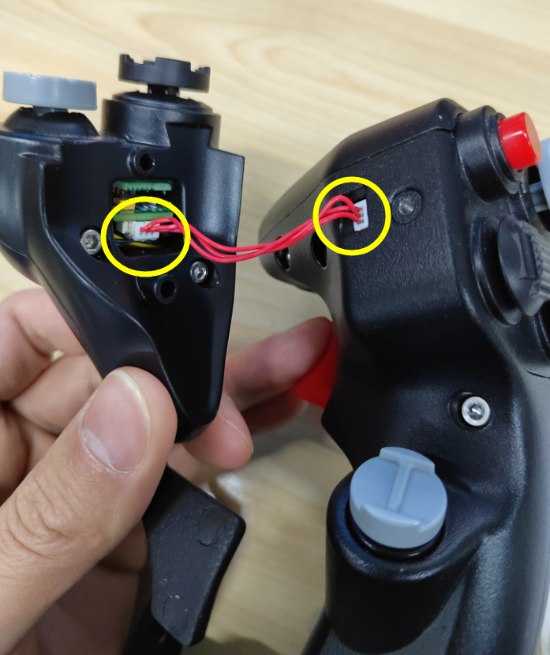
- Please unplug and re-plug the wire bundle in motherboard socket and check if the problem is resolved.
