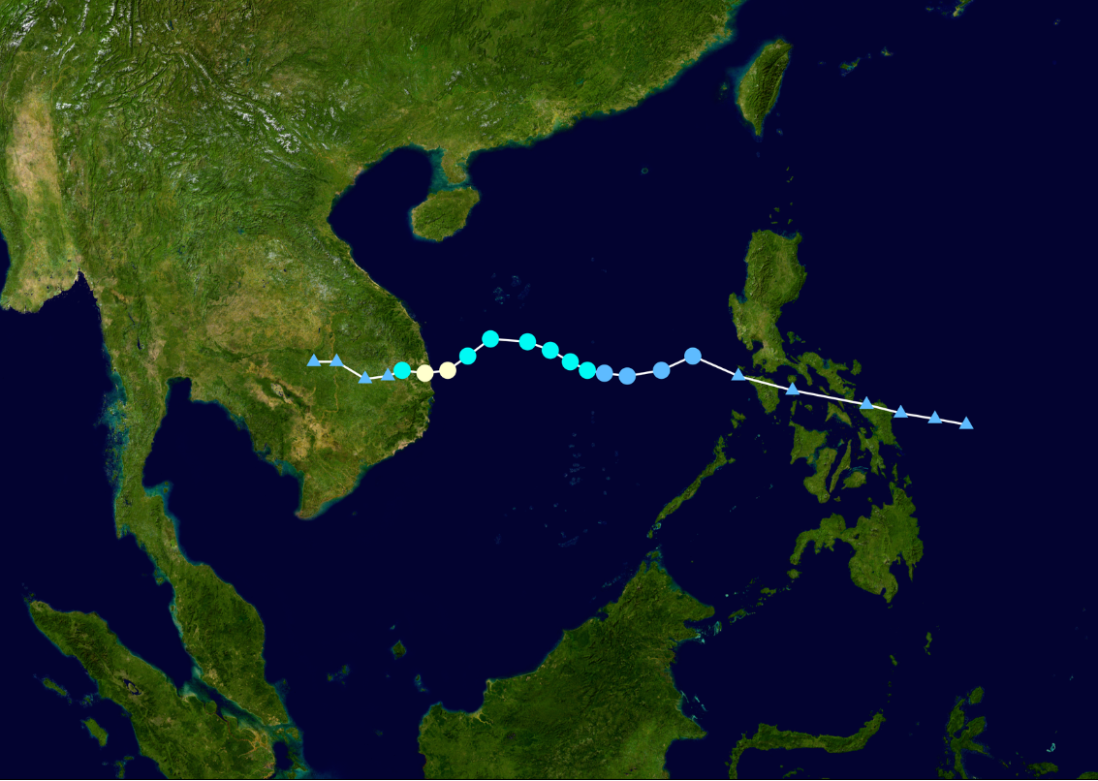
Map shows the track of Typhoon Iris which struck Vietnam on November 4, 1964.

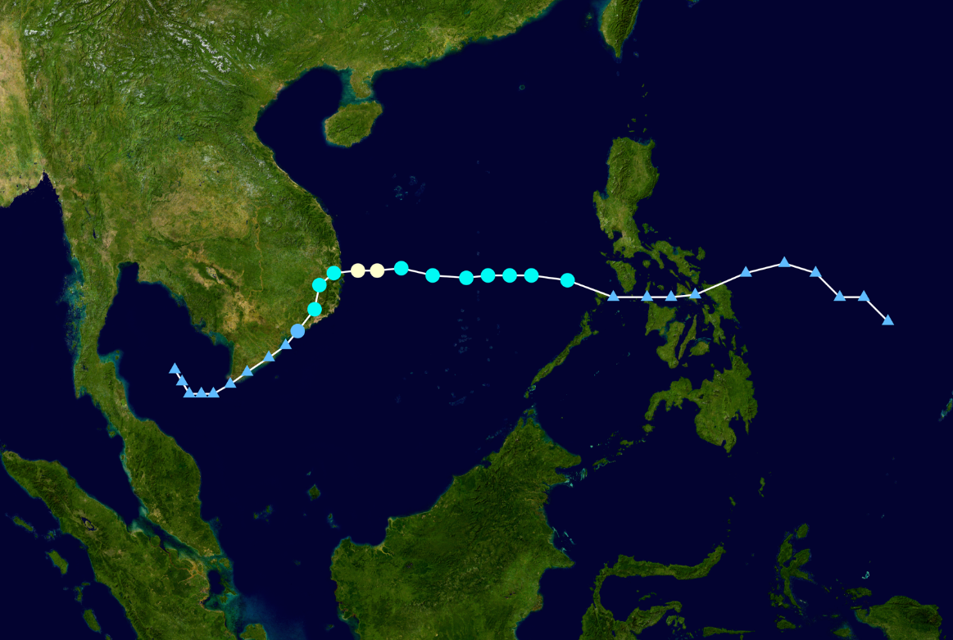
Map shows the track for Typhoon Joan that hit Vietnam on January 8, 1964.

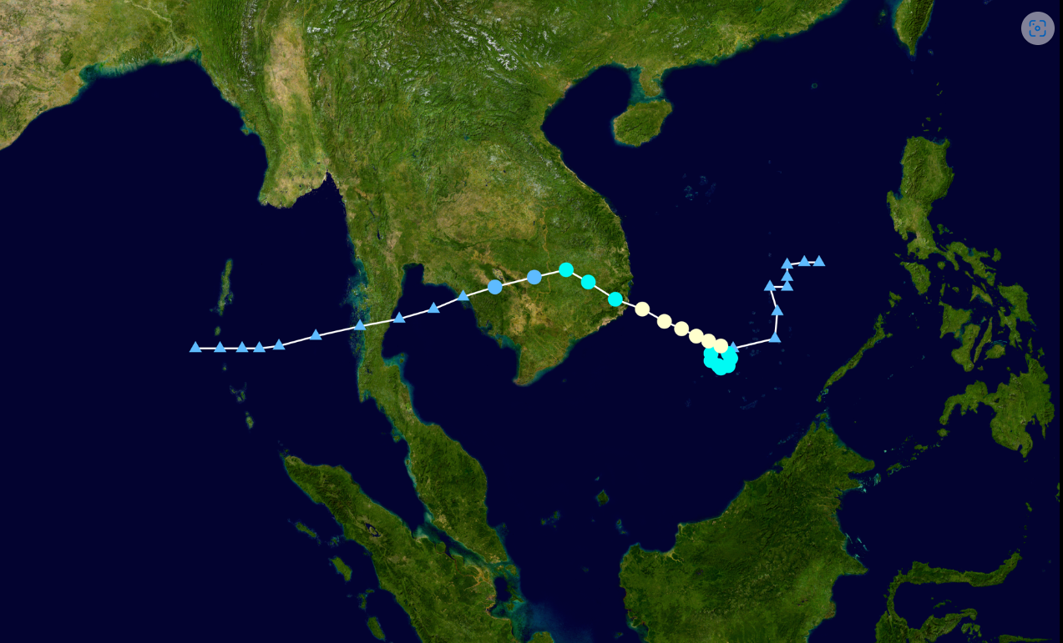
Map that shows the track for Typhoon Kate that struck Vietnam on January 16, 1964.

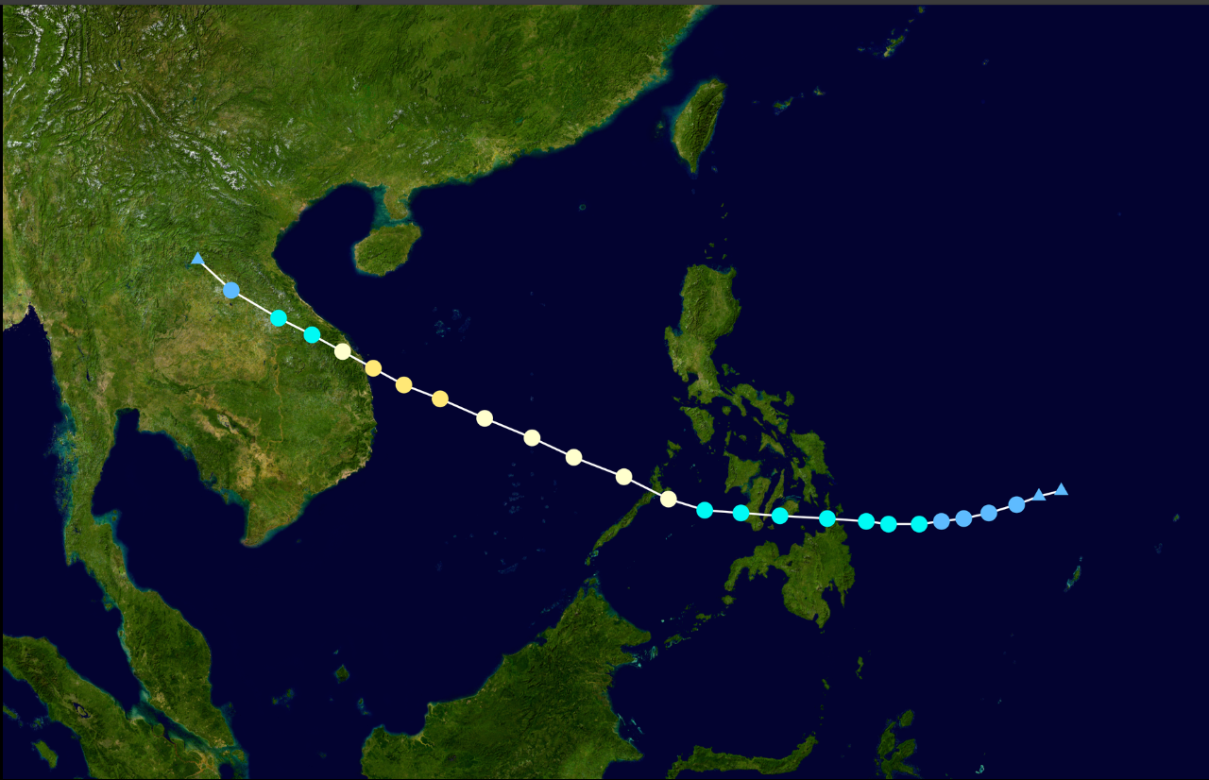
This map shows the track for the 1971 Typhoon Hester that struck Vietnam.

