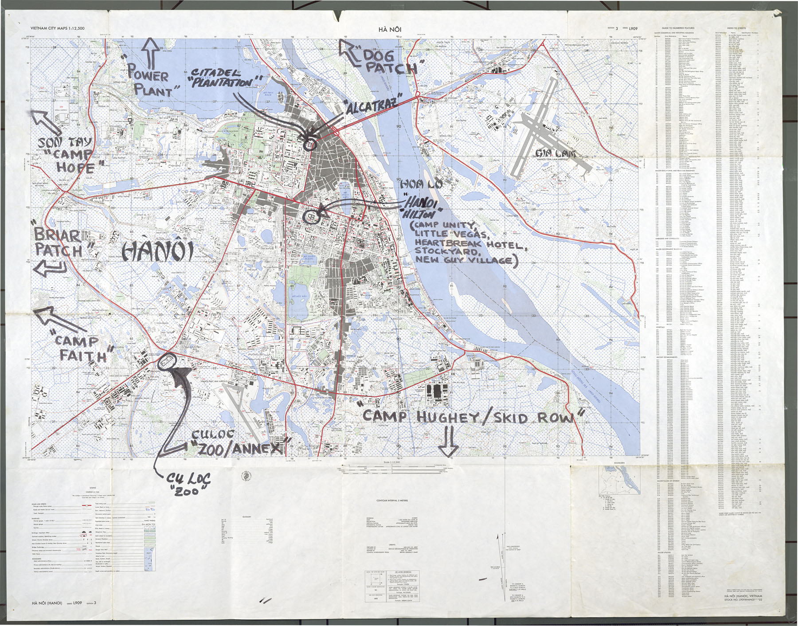
URL for image showing American POW camps around Hanoi during Vietnam War: 090424-F-1234P-009.JPG (1800×1412) (defense.gov)
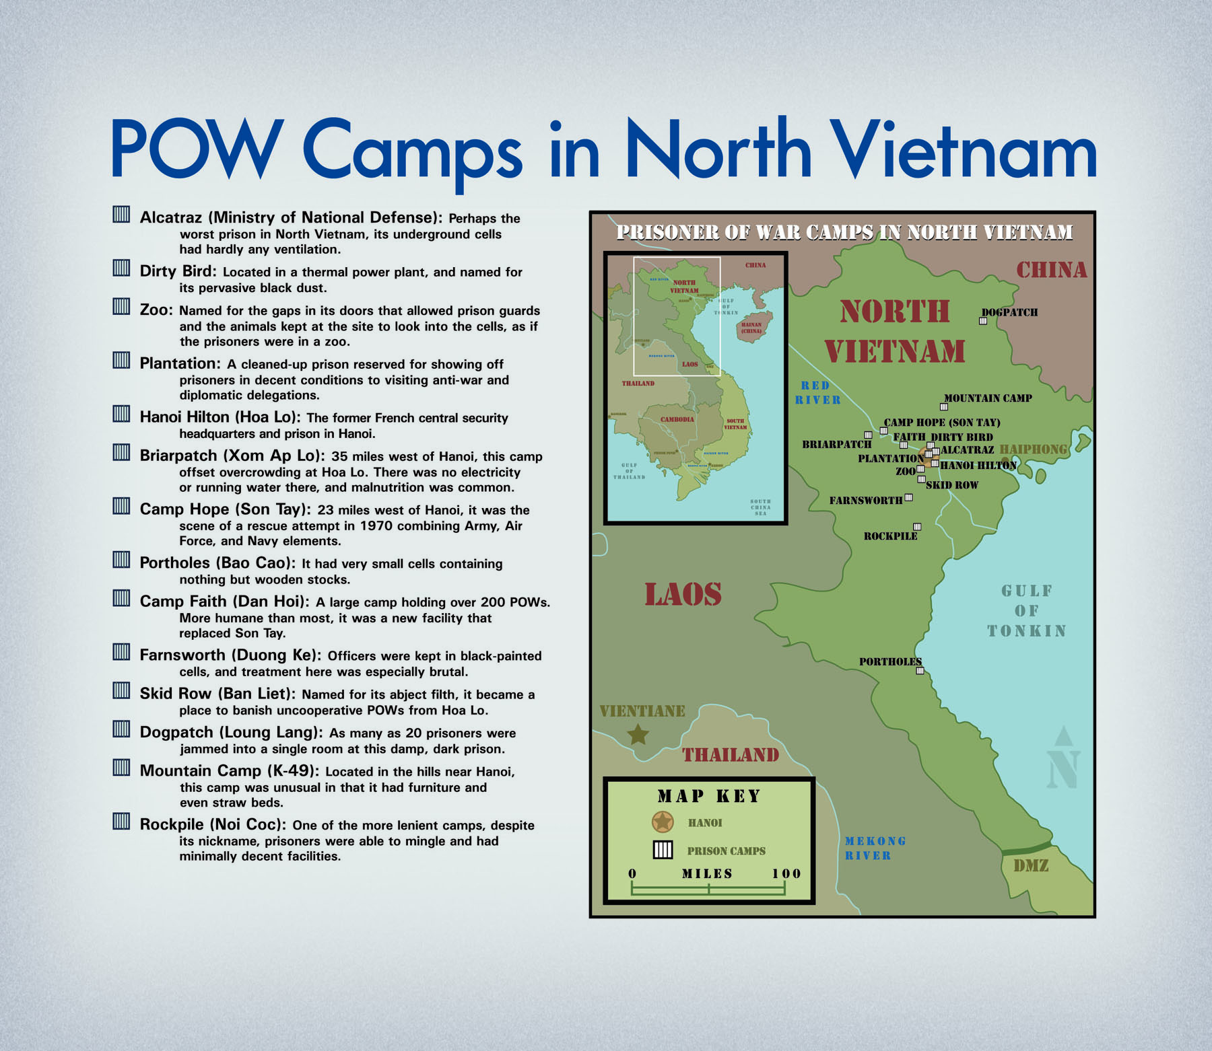
URL for image showing various American POW camps in Northern Vietnam during the Vietnam conflict: 090424-F-1234P-010.JPG (1800×1562) (defense.gov)

