
Photo: The owl ancient bird that represents wisdom

American General Dynamics F - 24 “Owl” (USAF United States Air Force)

European Airbus Defense “Firefox” (version)
(European companies partnership)
(Airbus EADS Leonardo SAAB and others)

(Inspired from “Star Trek” movies this is the Federation adversary Klingon bird of prey spaceship)
(F – 22 Raptor and Eurofighter Typhoon Replacer on USAF and in Europe with codename “Firefox”)

(European Fighter Replacement Projected Date Starting in year 2060 no year yet for USAF that could be sooner)

General Specifications
(Next are 13 Specifications that could be optional on American and European versions)

6th Generation Multi-role Fighter

1.Clock Device

2.UAV (Unmanned Air Vehicle) and Drone Capability

3.No Noise Flight

4.Ultra Large Radar

5.Vertical Takeoff and Landing

6.“Passive” Artificial Intelligence

7.Space Flight Capability

8.Cargo Transport Capability

9.More Than 2 Crew Members Availability

10.Navy Ships Full Resources Availability

11.Full Centric Information System

12.Low Power Feature for Flight and Weapons Systems

13.Special Night and Day Vision

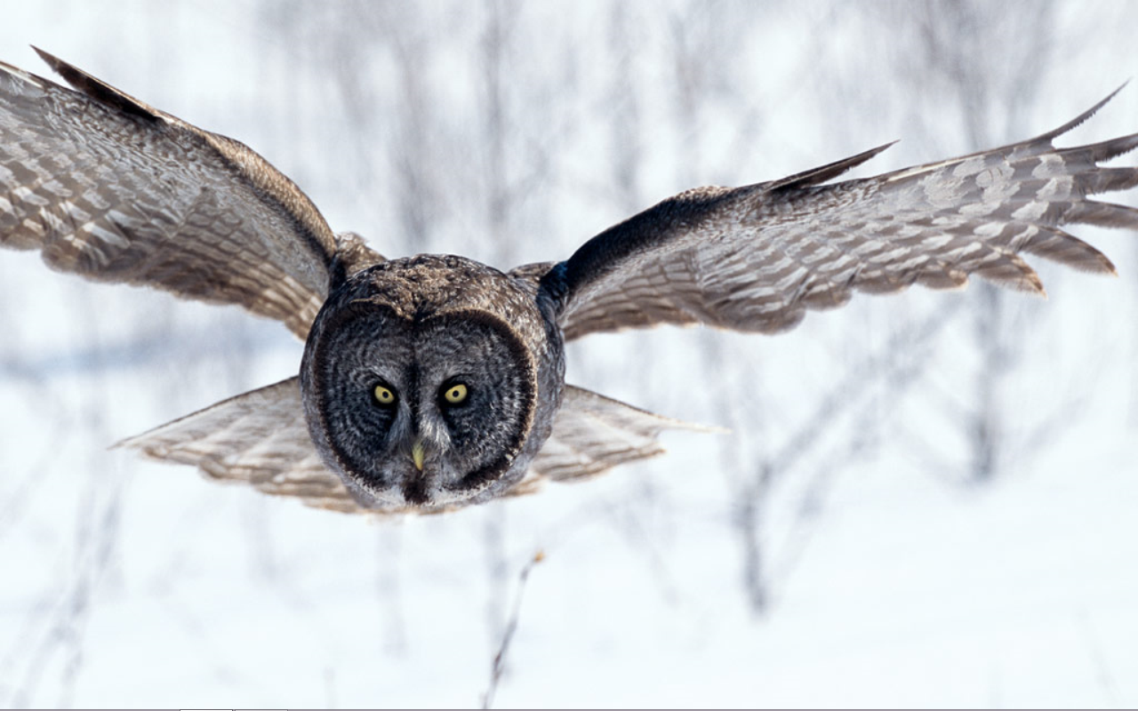
Photo 2: The owl hovering over the prey
Variable geometry on the wings is crucial for the vertical take off and landing feature
This is a 6th Generation Fighter so older features of older fighters should and could be implemented for example “Stealth” or “Faster than sound speed”
Guns or another “weapons” on the wings tips are key to the fighter because of aerodynamic requests
Cargo transport in a fighter is a new feature that should be given a moderate attention on the final design model
Next are photos and drawings from the model that should resemble the actual aircraft/spaceship model that could be constructed in a “similar” or larger scale like the one from “Star Trek”

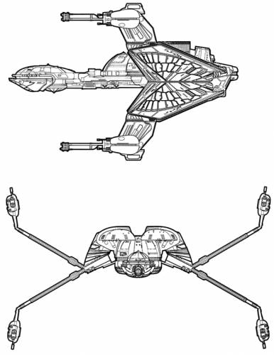
Side and Front View with Variable Geometry representation in the Wings
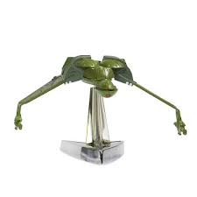  3D Front View down angle on the wings | 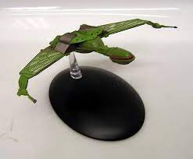  3D Front View 0º angle  on the Wings
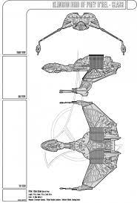

2D Front Side and Upper Views

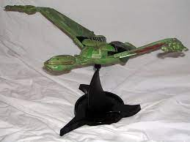
3D View with upper angle wings position

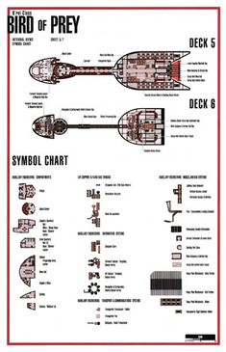
2D View of internal design (on a later version)
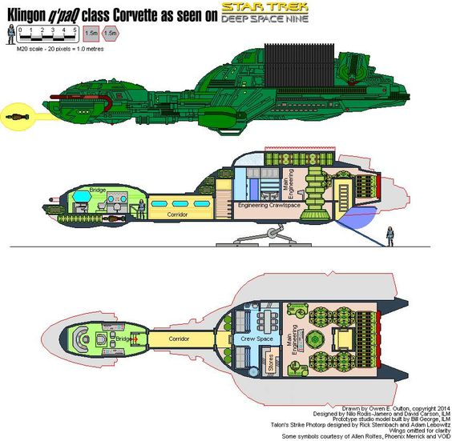
2D View of internal design
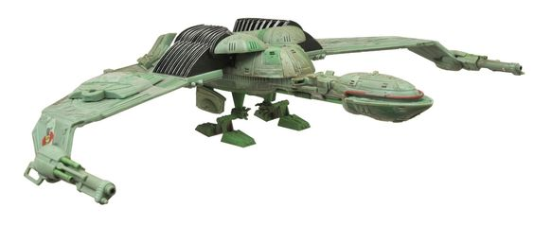

3D View on landed position similar to a bird with the capability of landing almost anywhere

The vertical take-off and landing system of the spaceship/aircraft should be a little problematic to implement even thou in my opinion the Harrier (British aircraft of the 80s) should be a nice start of ideas to help achieve the final objective.
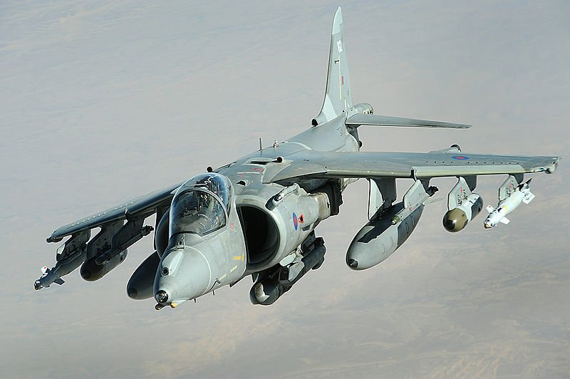
Photo 3 Harrier in horizontal flight
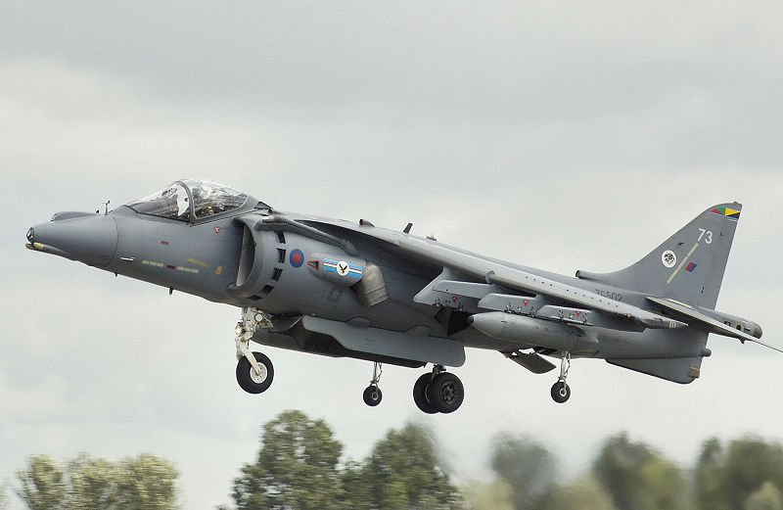
Photo 4 Harrier in vertical flight
Conclusion
The Bird of Prey from “Star Trek” fiction movies and TV shows with its unique features and capabilities should be a nice source of ideas to get this project in the final stage. This project is called F – 24 “Owl” and it represents the successor of the air superiority fighter F – 22 “Raptor” in the USAF and Eurofighter Typhoon in Europe. In my opinion NATO should support the development of this project because many older jets are reaching the age limit like the F-16 “Falcon” or F-18 “Hornet”. In Europe the “Tornados” and many other older jet fighters are also in their final age of service. So as the policy that the multi-role fighter could replace other dedicated mission fighters and in this way reduce costs in maintaining a larger fighter fleet implemented in the last century until now. I strongly recommend that the F – 24 should be the next century Air Force aerospace ship that will lead the NATO forces in its goals.

