-- To change "Menu communication" location
--------------------------------------------------------
Path : H:\01 - Jeux\DCS World\Scripts\UI\RadioCommandDialogPanel\CommandDialogsPanel.lua

Note : It's very usefull to do this in order to use your touch screen to select the desired function of the Comunication menu

Line 181

function initialize(self, menus, rootItem, dialogsData, parent)

--print('CommandDialogsPanel.initialize()')
local heightMenu = 0
local menuWidth = CommandMenu.getMenuWidth()
--UI
do
local screenWidth, screenHeight = Gui.GetWindowSize()
local height = CommandMenu.getMenuHeight()
local window = DialogLoader.spawnDialogFromFile('Scripts/UI/RadioCommandDialogPanel/CommandDialogsPanel.dlg')
-- Position of the communication menu – you can add different configuration, depends on your airplane
-- window:setBounds(screenWidth - menuWidth, 0, menuWidth, height) -- ORIGINAL
-- window:setBounds(1920*2 - menuWidth, 0, menuWidth, height) -- central up right corner
-- window:setBounds(1920*2 - menuWidth, 1080 - height, menuWidth, height) -- Main screen down right
window:setBounds(2720, 1365, menuWidth, height) -- F14 configuration Pilot VDI
-- window:setBounds(2310, 1430, menuWidth, height) -- A29 configuration Pilot MFCD L
-- window:setBounds(2470, 1446, menuWidth, height) -- T45 configuration Pilot MFCD L

Example :

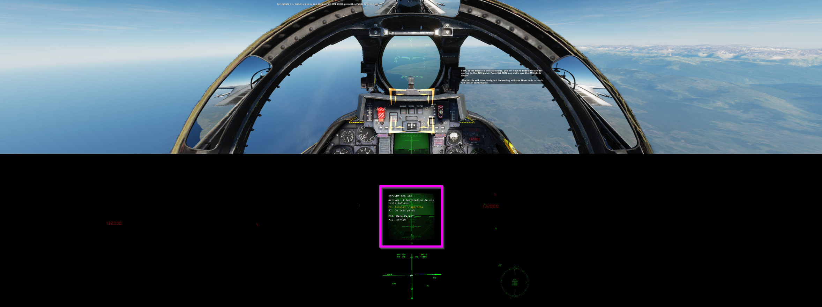

-- Control commande F14 (Hotas axis position) – Same for all other aircraft
--------------------------------------------------------
H:\01 - Jeux\DCS World\Mods\aircraft\F14\Cockpit\Scripts\ControlsIndicator\ControlsIndicator_page.lua

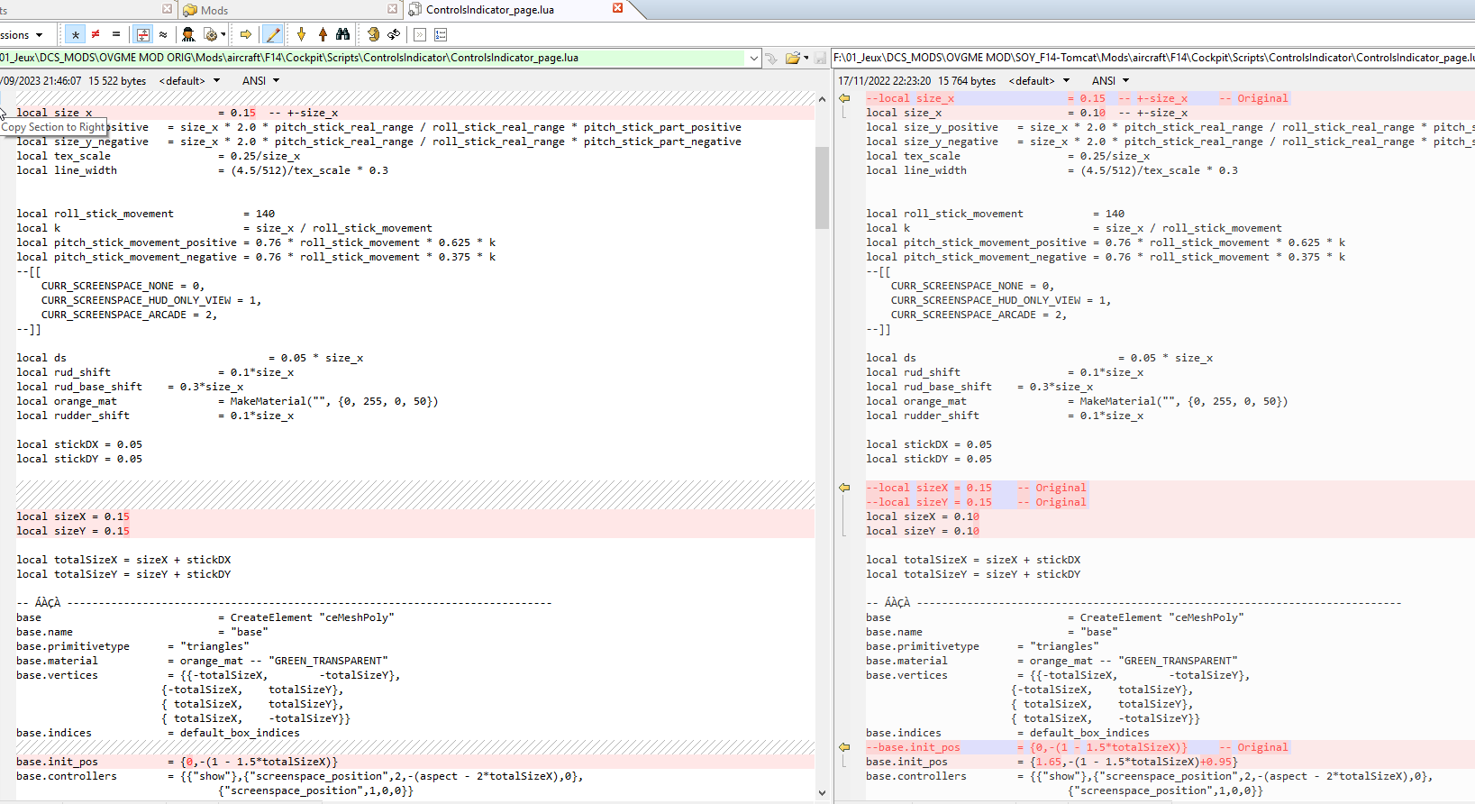

-- To change DCS "Kneeboard" location
--------------------------------------------------------
H:\01 - Jeux\DCS World\Scripts\Aircrafts\_Common\Cockpit\ViewportHandling.lua

Line 23
-- dedicated_viewport = {default_x,default_y,default_width,default_height} -- ORIGINAL KNEEBOARD
dedicated_viewport = {4520,1080,565,930} -- Depend on where you want your DCS kneeBoard

Example :

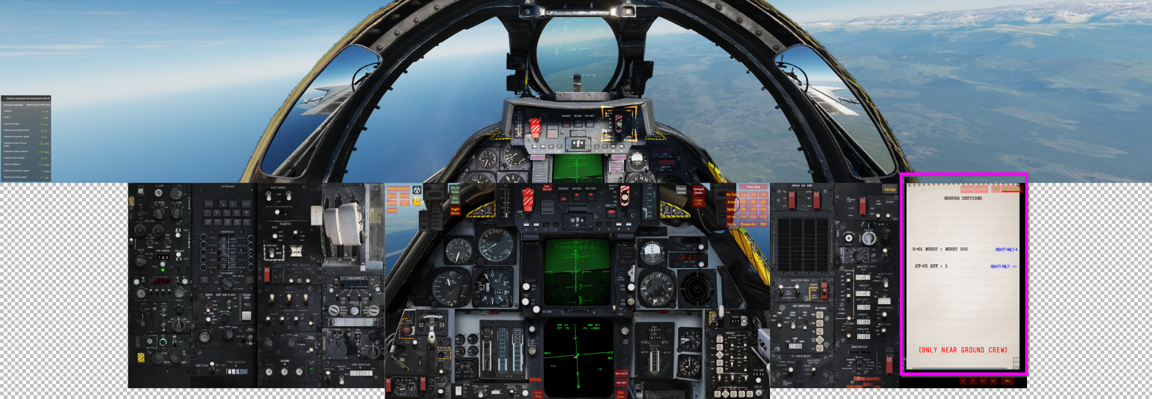

-- To move the "COM menu" location
--------------------------------------------------------
H:\01 - Jeux\DCS World\Scripts\UI\gameMessages.lua

Add the following yellow lines to limit the TUTO message to the right corner of the middle screen

function create()
local localization = {
}

window = DialogLoader.spawnDialogFromFile('Scripts/UI/gameMessages.dlg', localization)
main_w, main_h = Gui.GetWindowSize()
main_w = 3840 – PATCH: Line added to set the Tutorial/Mission messages to the center screen right corner
window:setBounds(0, 0, main_w, main_h)

…
…
…

autoScrollTextTrig:setBounds(getLentaTriggerBounds(0))
-- autoScrollTextRadio:setBounds(0, 20, main_w - 650, main_h - 20) -- ORIGINAL
autoScrollTextRadio:setBounds(1940, 20, main_w - 650, main_h - 20) -- PATCH: Set the radio messages to the center screen left corner

Example :

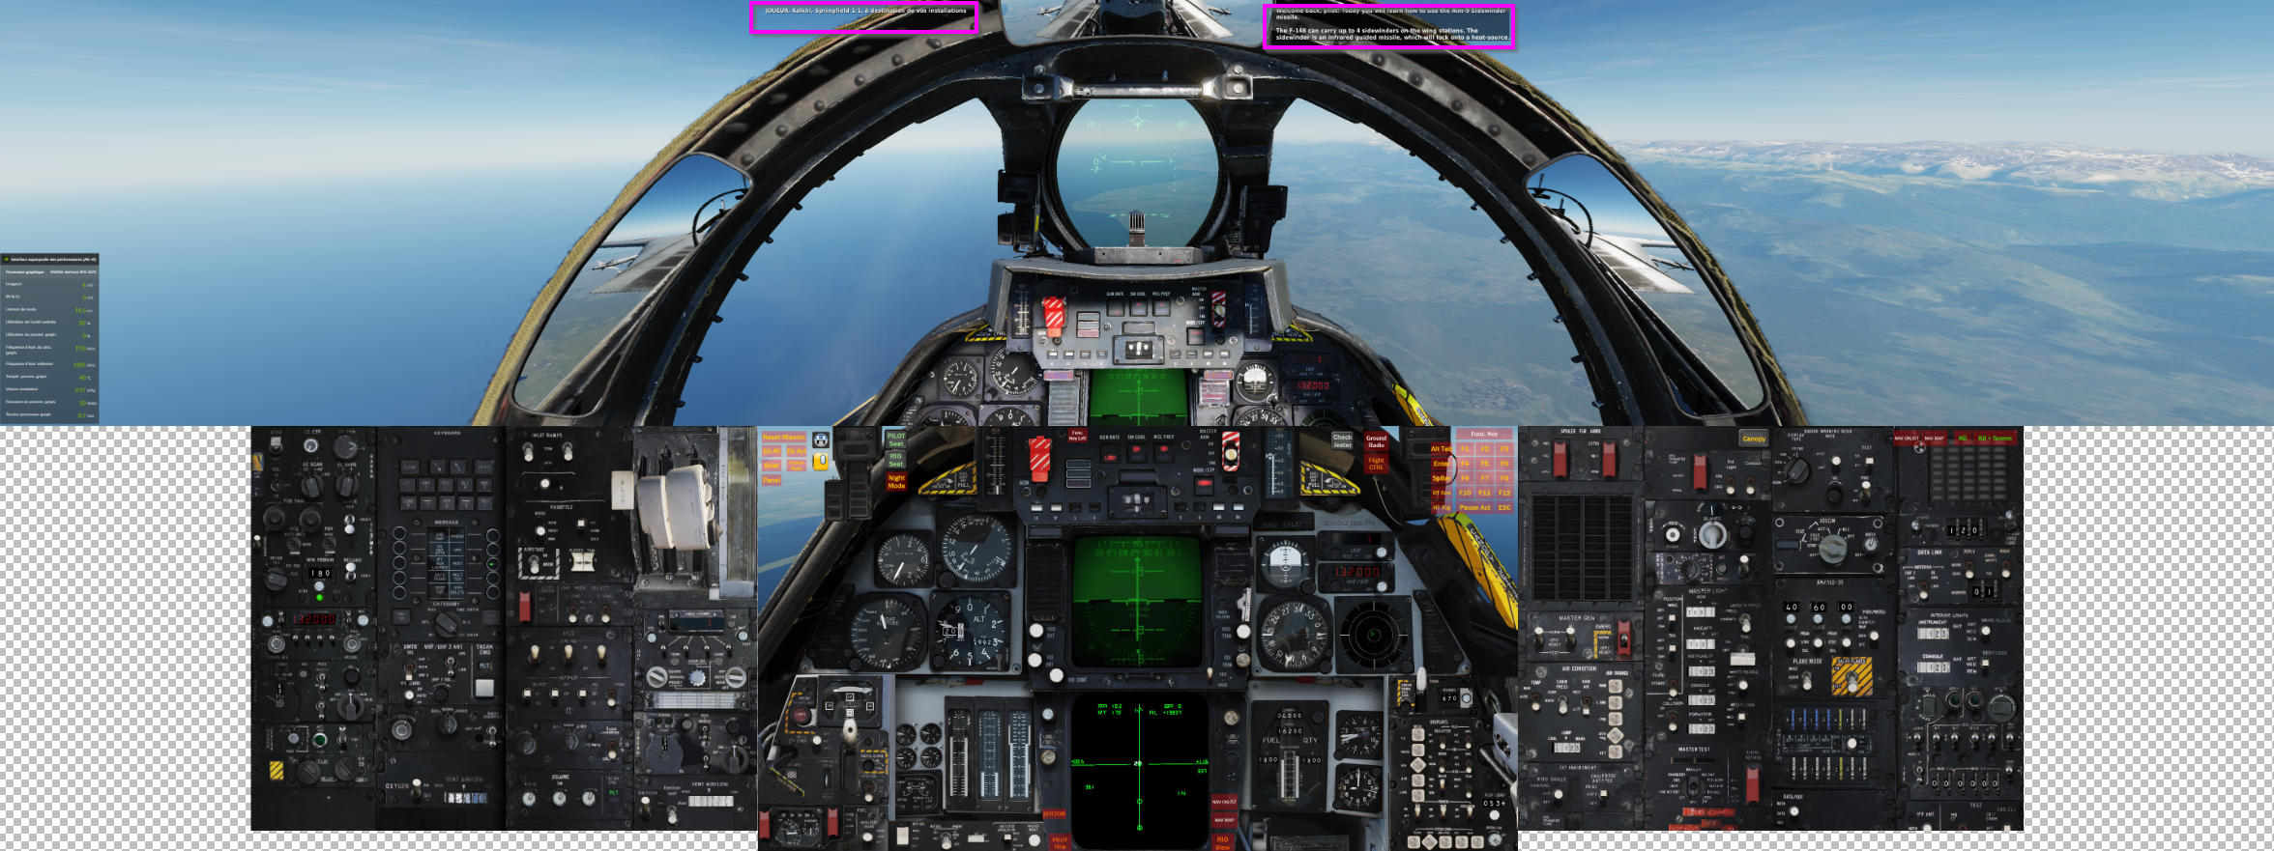

-- Turn off cockpit Viewport
--------------------------------------------------------
To turn off cockpit MFDs but still have them exported to other monitors:-
Look in the file C:\Program Files\Eagle Dynamics\DCS World\Scripts\Aircrafts\_Common\Cockpit\ViewportHandling.lua for the Line (should be around line 81):-

purposes = {render_purpose.GENERAL,

And comment it out thus:-
purposes = {--render_purpose.GENERAL,

-----------------------------------------------------------------------------

