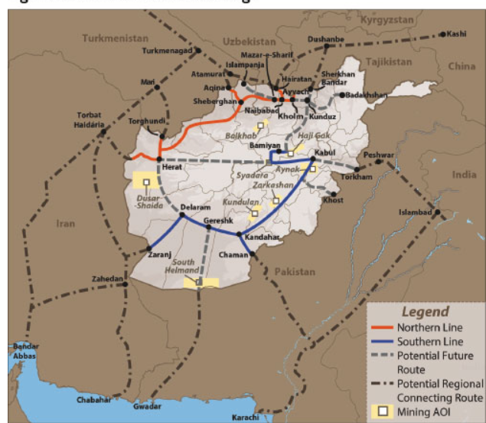
URL for the Afghan Railway Maps: The Afghanistan National Railway: A Plan Of Opportunity – Analysis – Eurasia Review
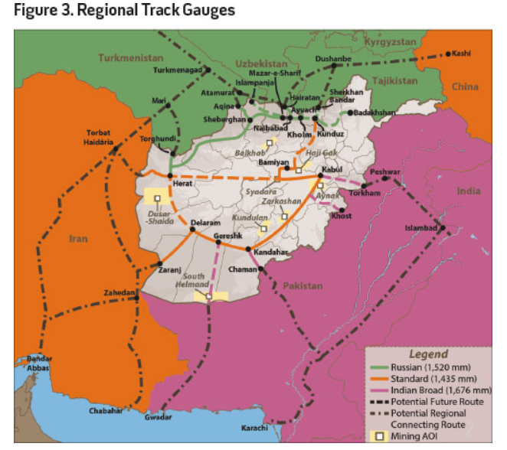
Different railroad gauges in Afghanistan.

