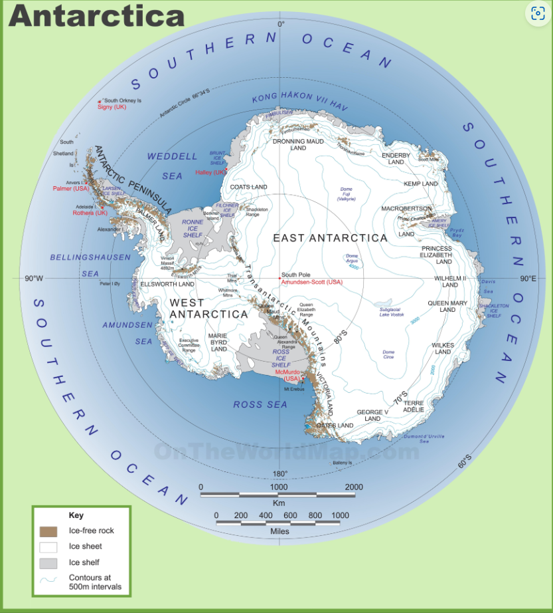
URL for the map: large-detailed-map-of-antarctica.jpg (3500×3865) (ontheworldmap.com)

