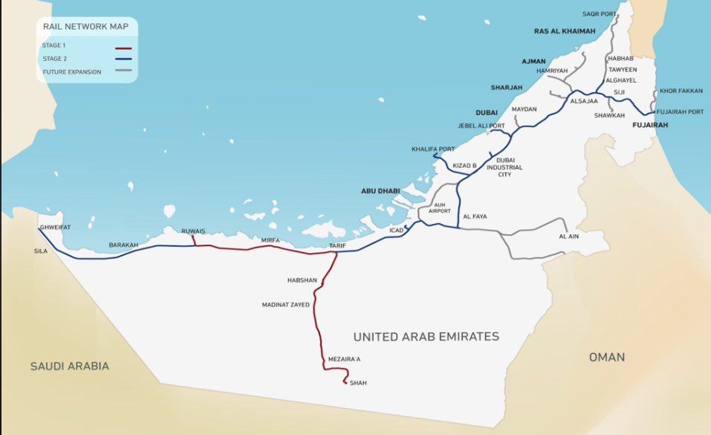
URL for the map: https://images.search.yahoo.com/search/images?p=etihad+rail+map+pdf&fr=mcafee&type=E210US739G0&imgurl=https%3A%2F%2Fwww.timeoutabudhabi.com%2Fcloud%2Ftimeoutabudhabi%2F2022%2F03%2F04%2Fetihad-rail-route-1024x683.png#id=4&iurl=https%3A%2F%2Fmybayutcdn.bayut.com%2Fmybayut%2Fwp-content%2Fuploads%2FEtihad-rail-project-4th-August-1024x640.png&action=click
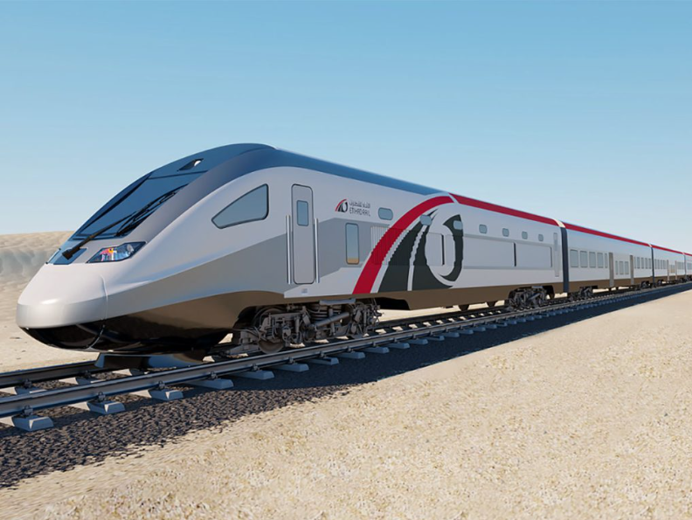
Image of an Etihad Railways high-speed passenger train.

