Procedure for troubleshooting intermittent lagging issues
- Connect the USB cable of product to the computer main board, so as to check whether HUB is normal.
- Modify the USB settings in the power options, and set the “selective pause” as “disabled.”
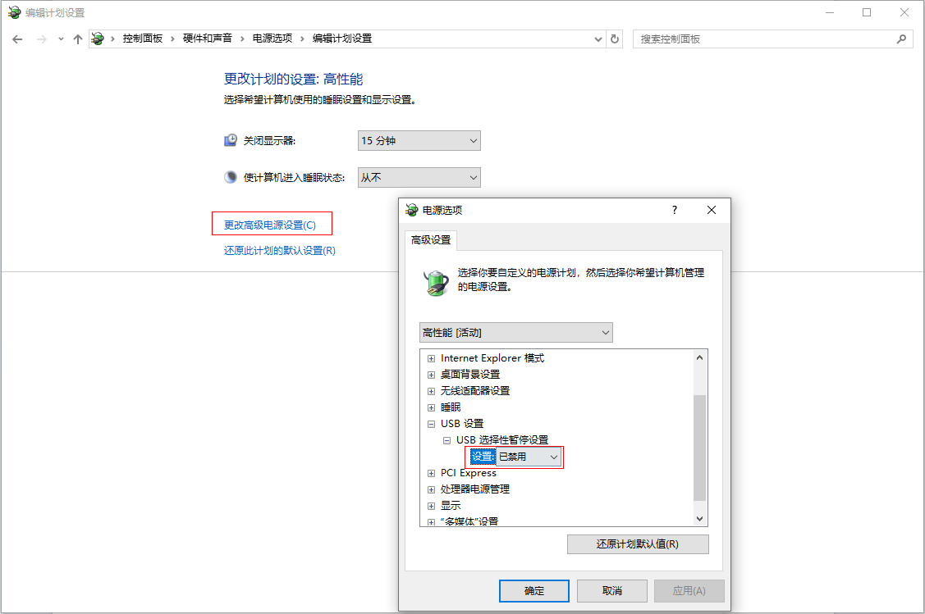
- Modify the power management of the USB input device in Device Manager, uncheck "Allow the computer to turn off this device to save power."
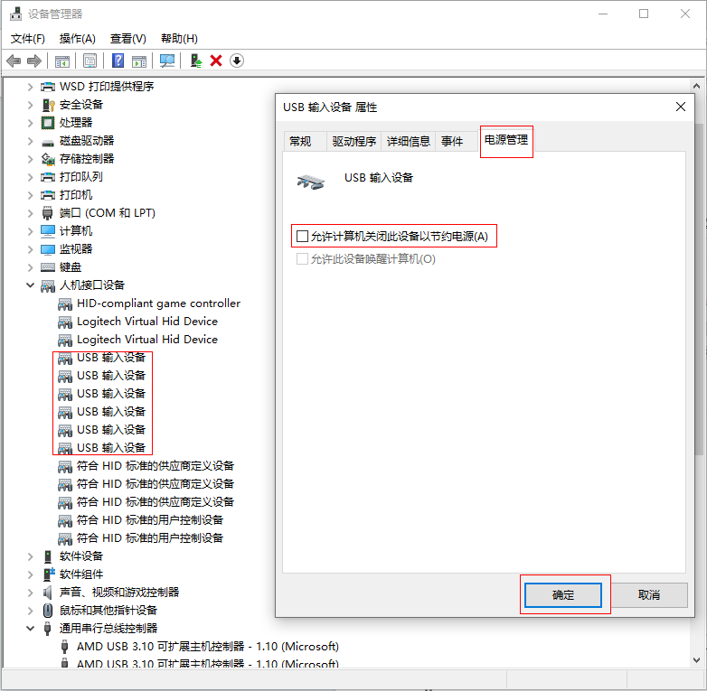
- Modify the power management of the Universal Serial Bus controllers in Device Manager, uncheck "Allow the computer to turn off this device to save power."

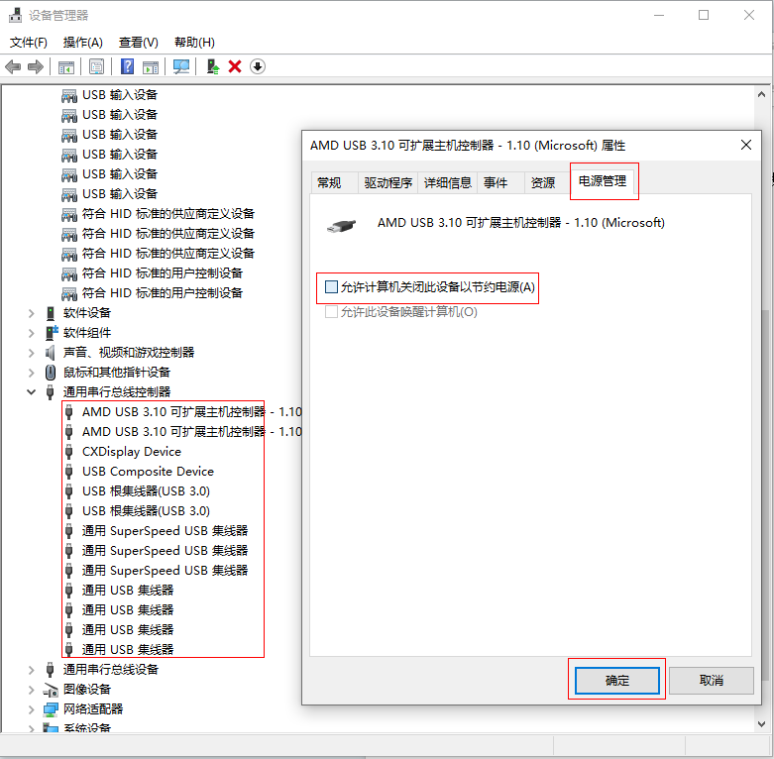

If the issue persists after setting as above, please keep simapp open and stay on the device testing page. If you encounter intermittent lagging issues again, please provide the following information to help us pinpoint the specific cause of the problem:
1. Observe the status of the device indicator lights - whether they are on, off, or blinking. If blinking, please provide the frequency of the blinking. Also, check if there are any changes in backlight brightness before and after the lagging occurs.
- Monitor the left-side logs in simapp for any disconnection records. Operate the axes and buttons on the joystick head and base to check if the signals are normal.
3. Open the device printer page to verify if the device name is correct.
4. Open the built-in Windows game controller and operate the axes and buttons on the joystick head and base to check if the signals are normal.
- Wait for 1 minute to see if the signal automatically restores.
- If the signal does not recover normally, try restarting the SimApp software only and observe if it returns to normal.
- If the signal still does not recover normally, without unplugging the USB cable, only restart the computer and observe if it returns to normal.

