1.Close the SimAppPro
2.Input %appdata%/SimAppPro in the address bar of Windows Explore, and press “Enter”.
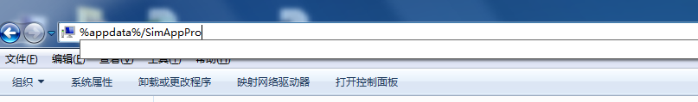
3.Open the config.json file with notebook, modify the following code as true, and save.
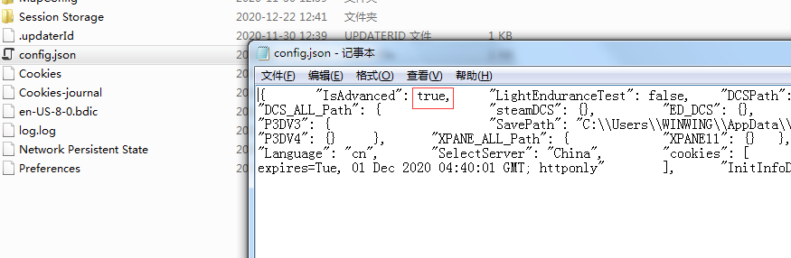
4.Restart the SimAppPro，and enter the device testing page, an option read “工厂设置”.
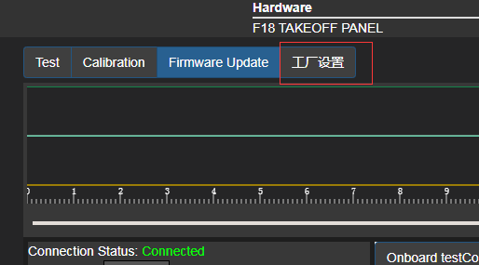
5.Click “工厂设置”and the following window will pop up. Then please toggle the abnormal axis and observe if the original axis data will response.

